**Node shapes and prediction key-**



## Pathways significantly altered by DEGS associated with calpastatin type I expression in T47D cells

**Pathways significantly inhibited by the DEGs associated with the expression of CAST I in T47D cells.** RHOGDI signalling pathway

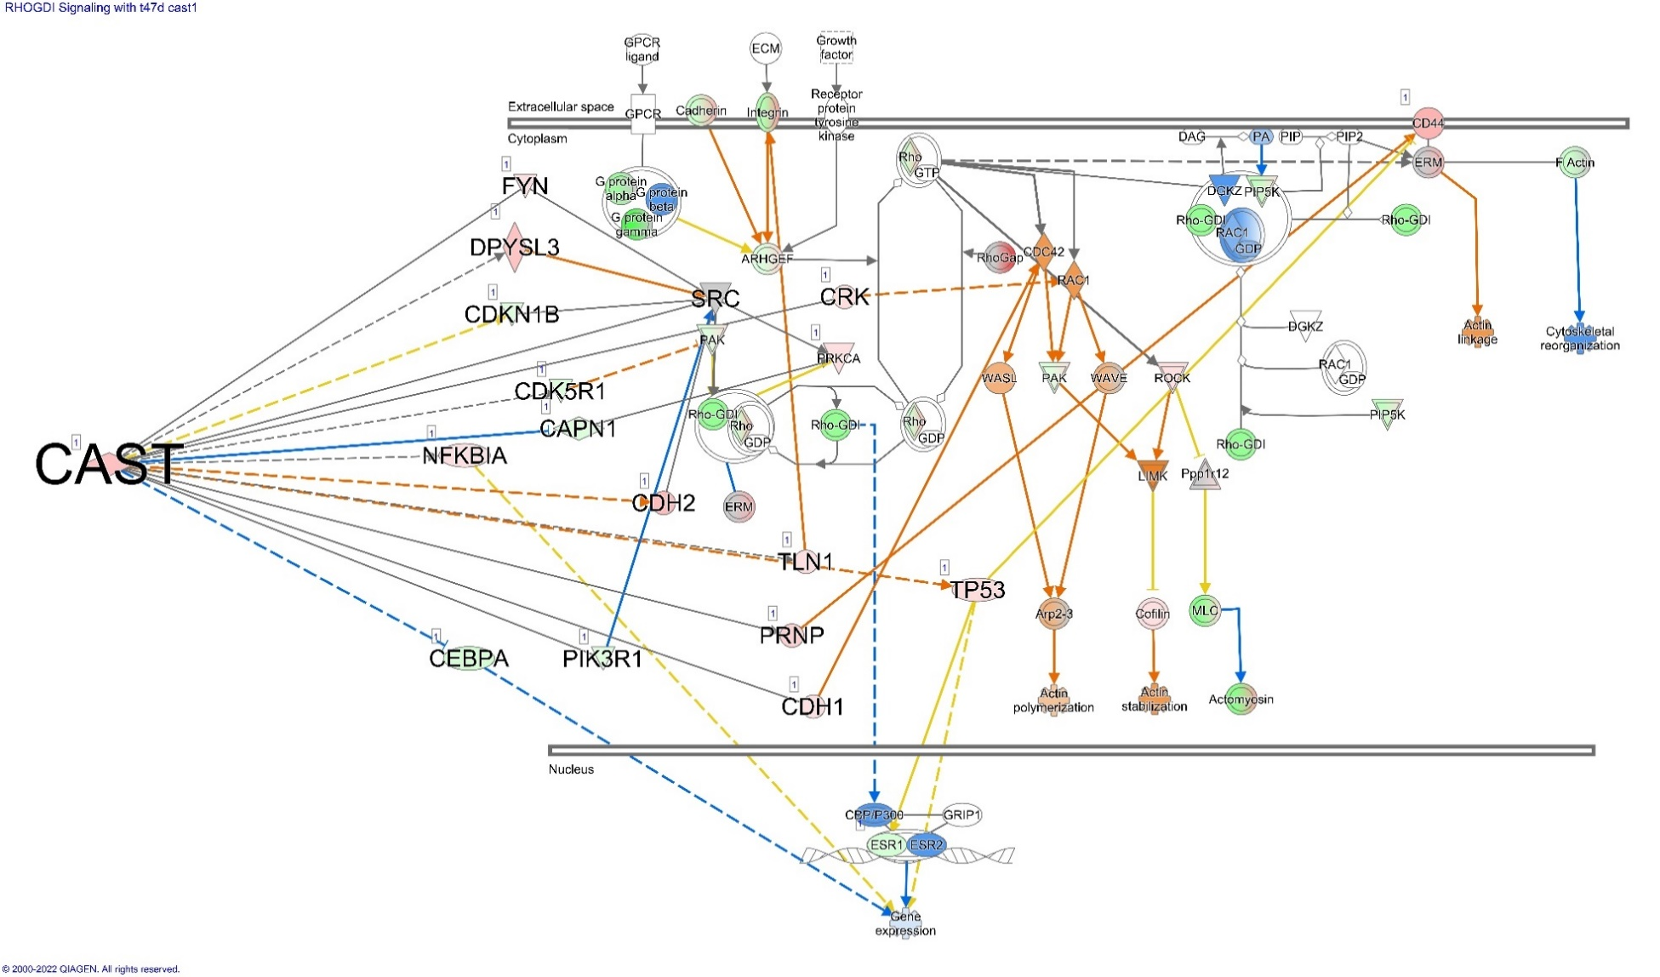

**Pathways significantly activated by the DEGs associated with the expression of CAST I in T47D cells.** (A) Osteoarthritis pathway, (B) Cholecystokinin/Gastrin-mediated signalling, (C) Inhibition of angiogenesis by TSP1, (D) Wound healing signalling pathway, (E) PI3K/AKT signalling, (F) Pulmonary fibrosis idiopathic signalling pathway, (G) Senescence pathway, (H) Tumour microenvironment pathway, (I) Cardiac hypertrophy signalling, (J) Hepatic fibrosis signalling pathway.

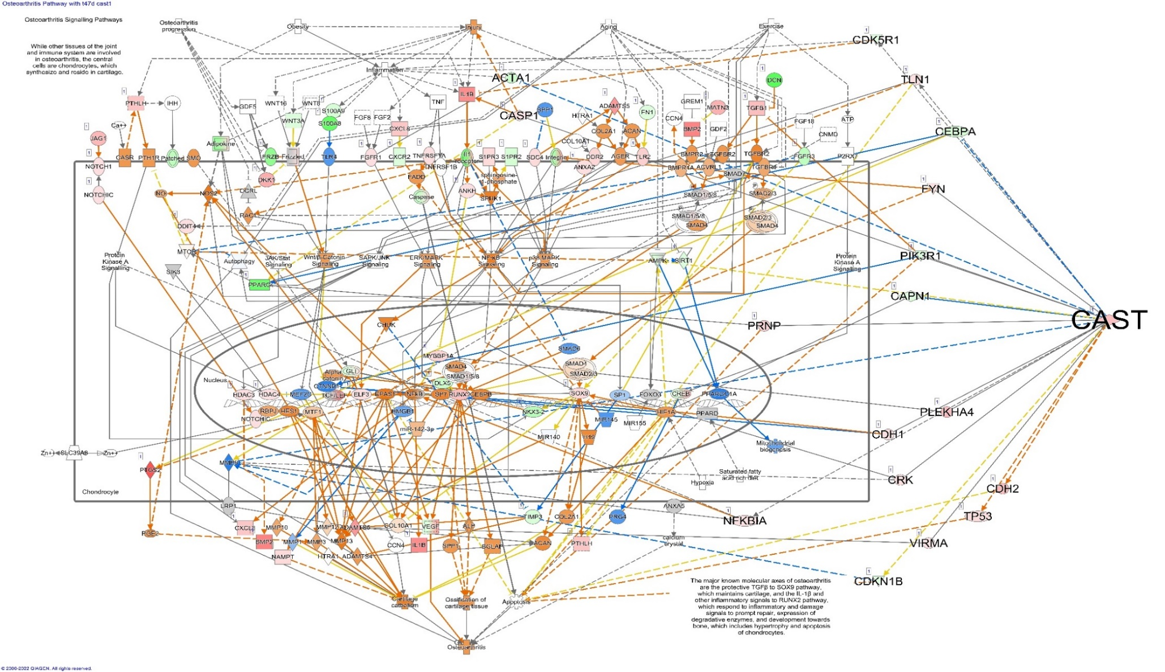

**A**

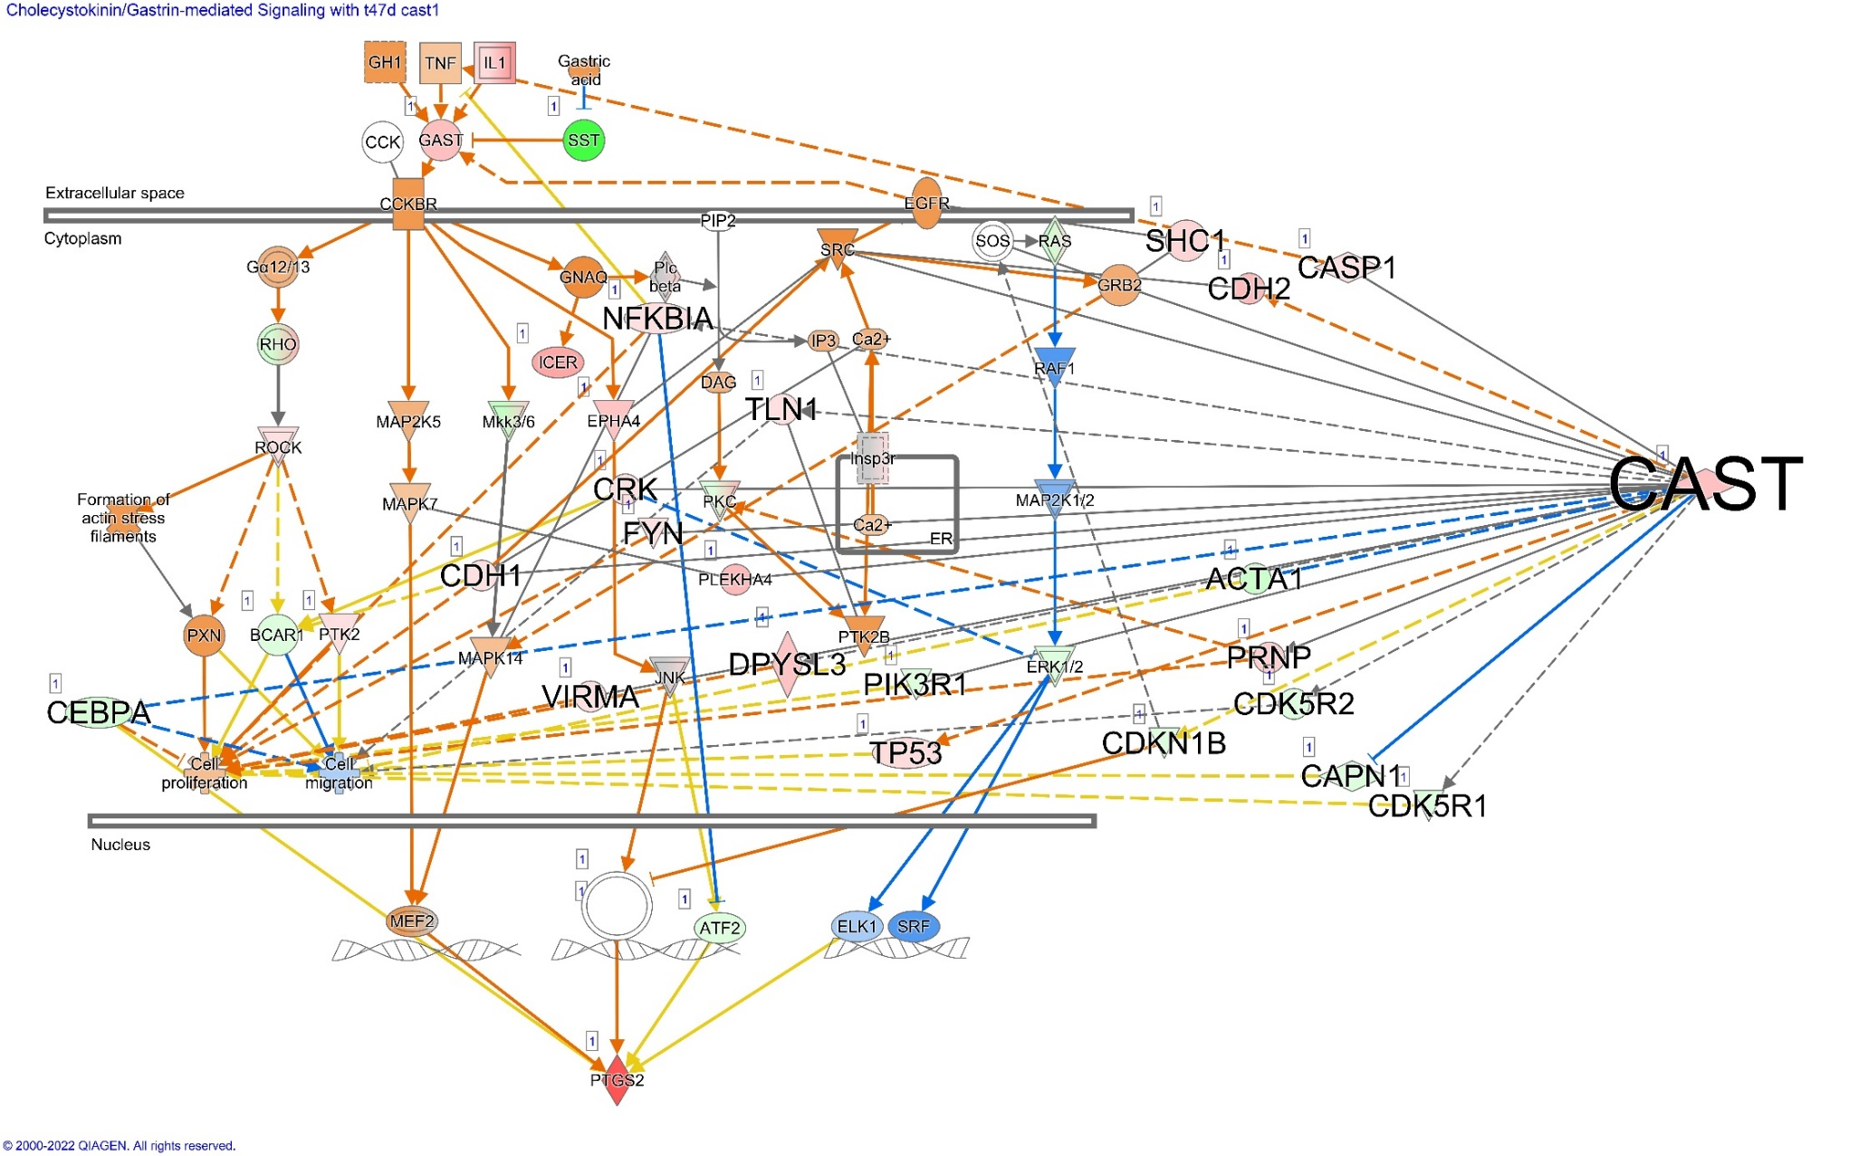

**B**

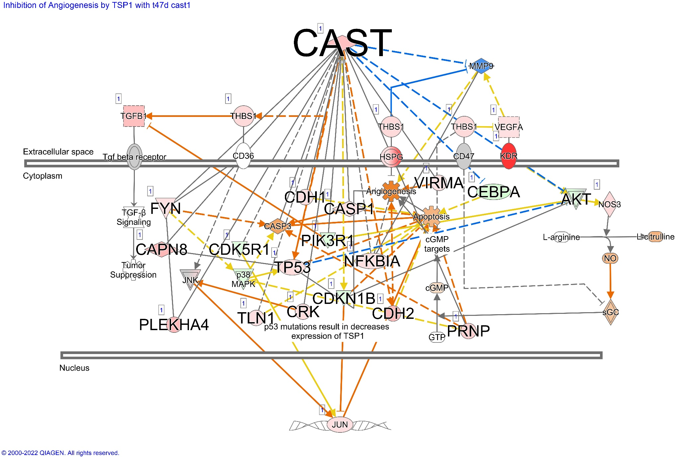

**C**

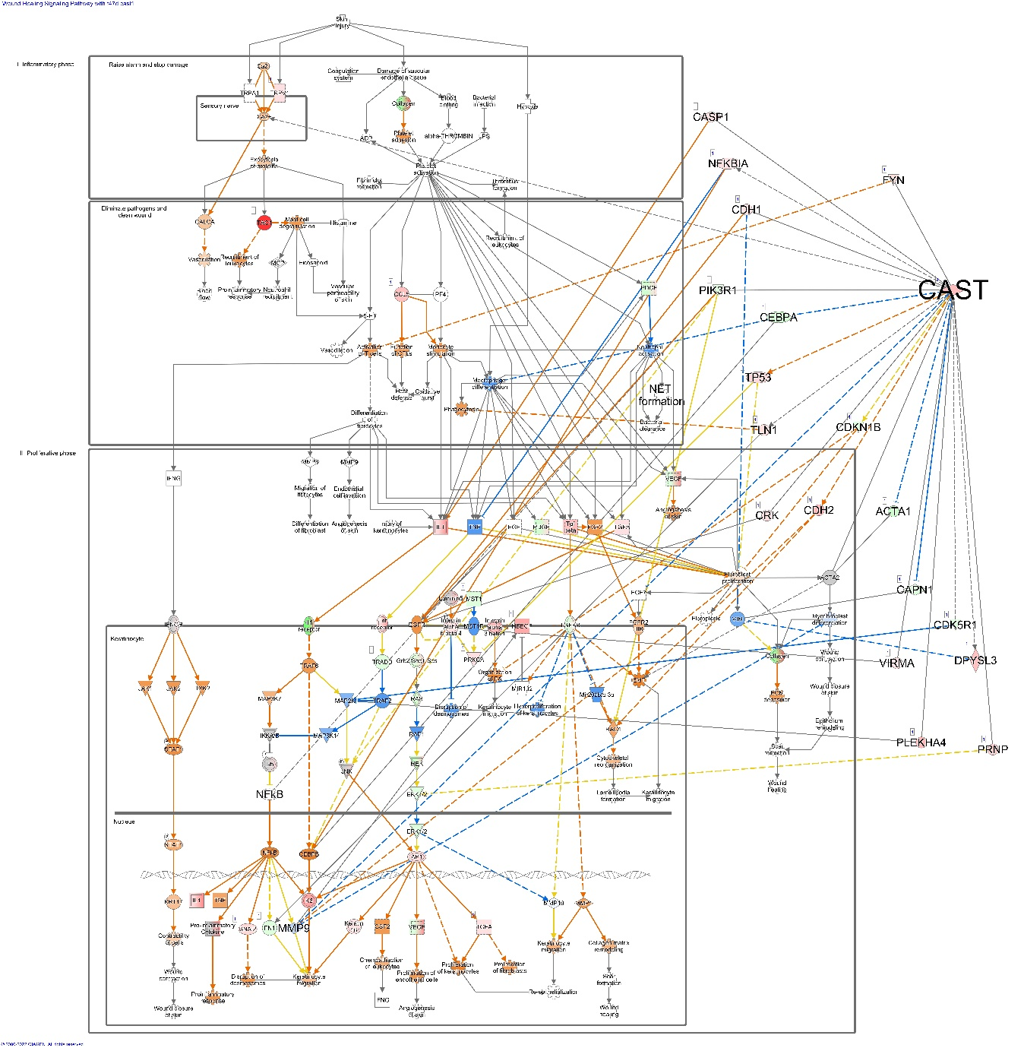

**D**

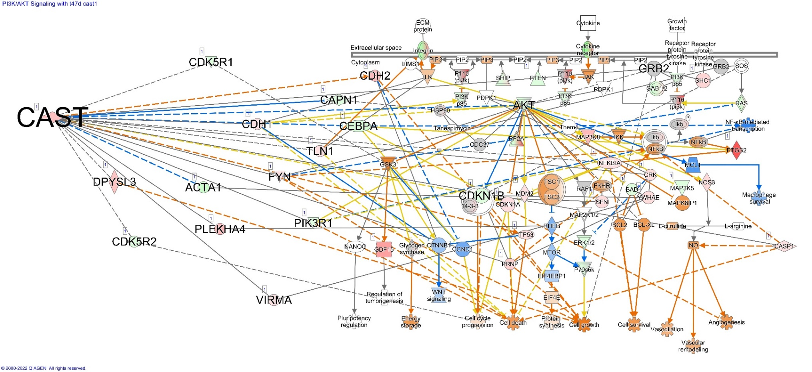

**E**

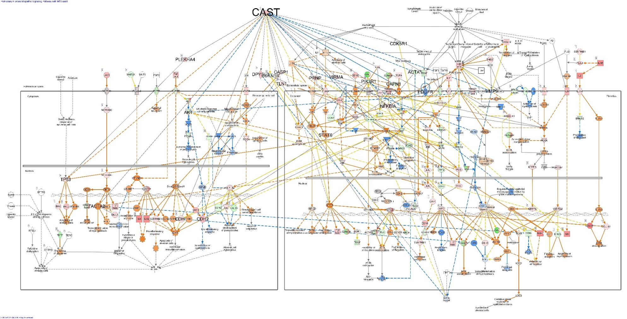

**F**

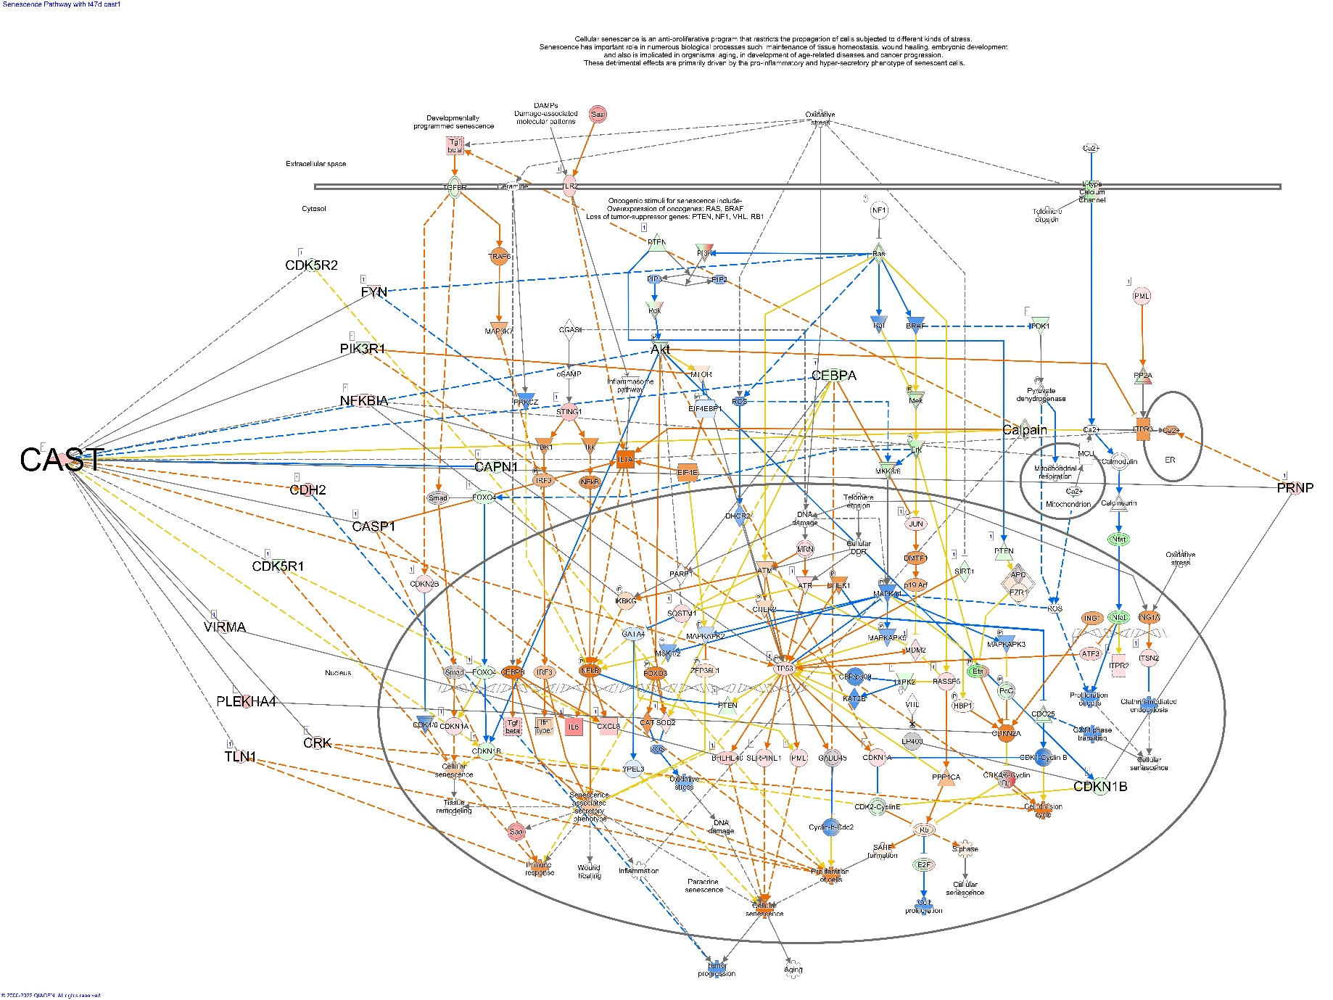

**G**

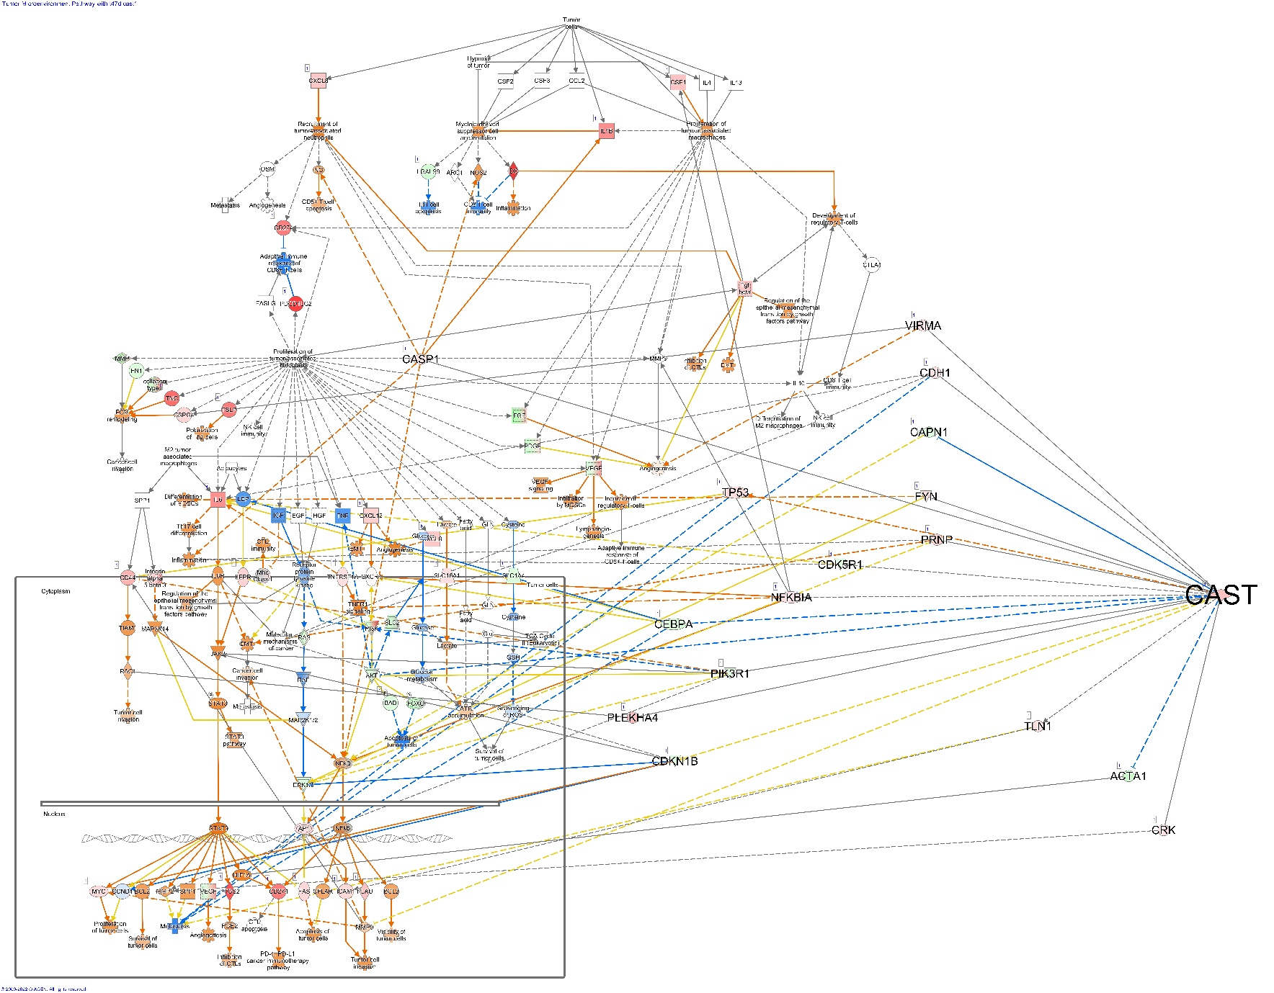

**H**

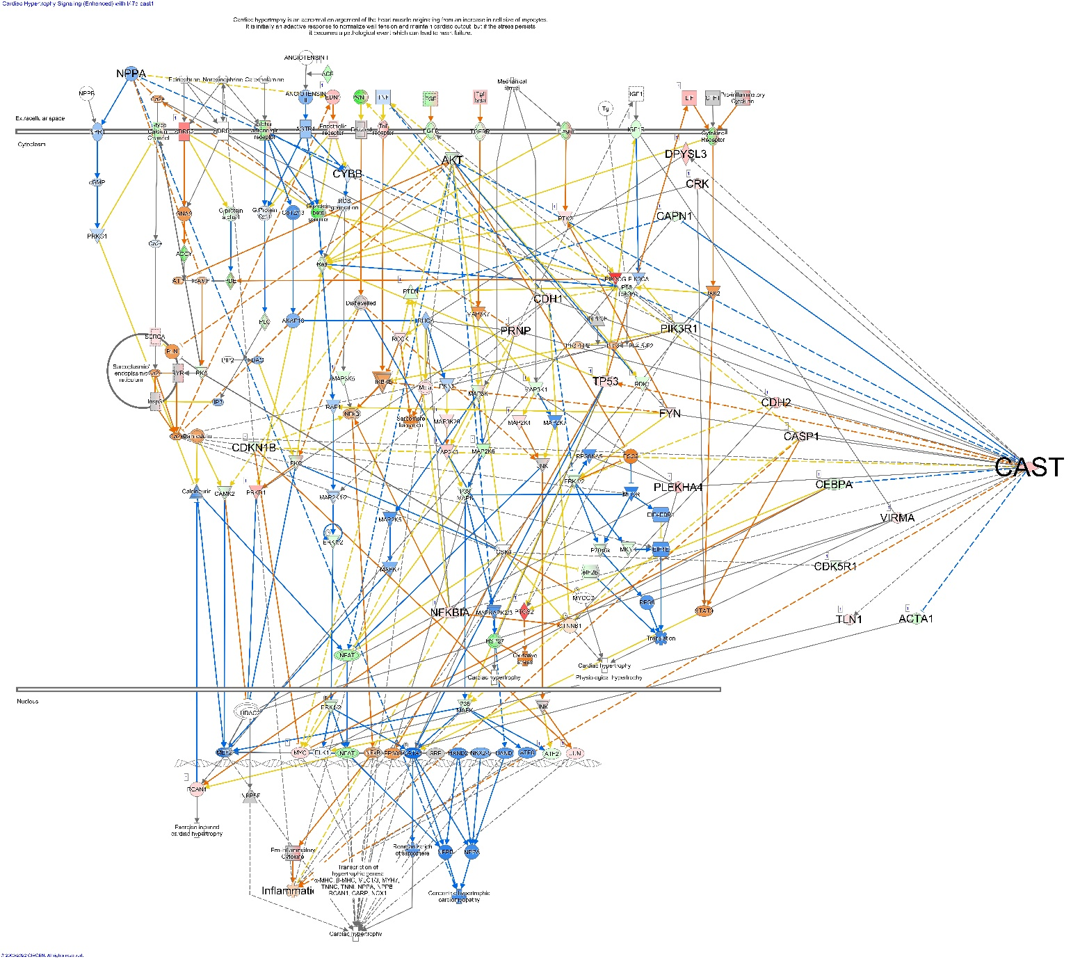

**I**

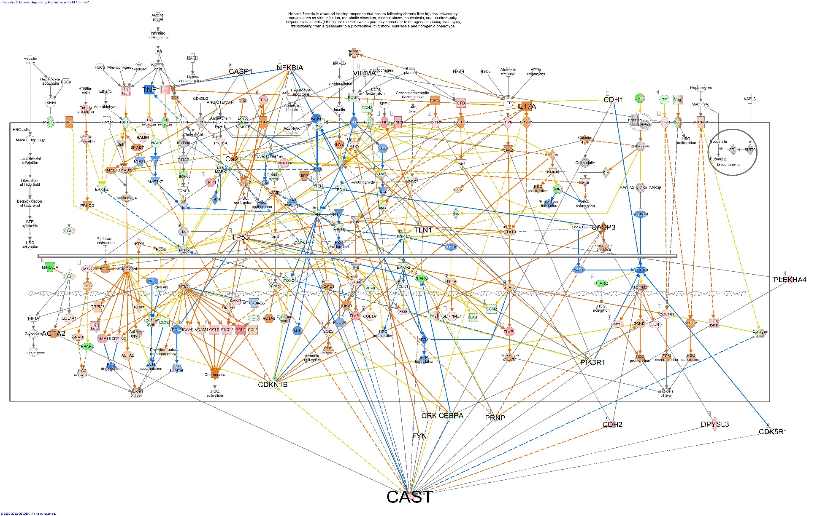

**J**

## Pathways significantly altered by DEGS associated with calpastatin type II expression in T47D cells

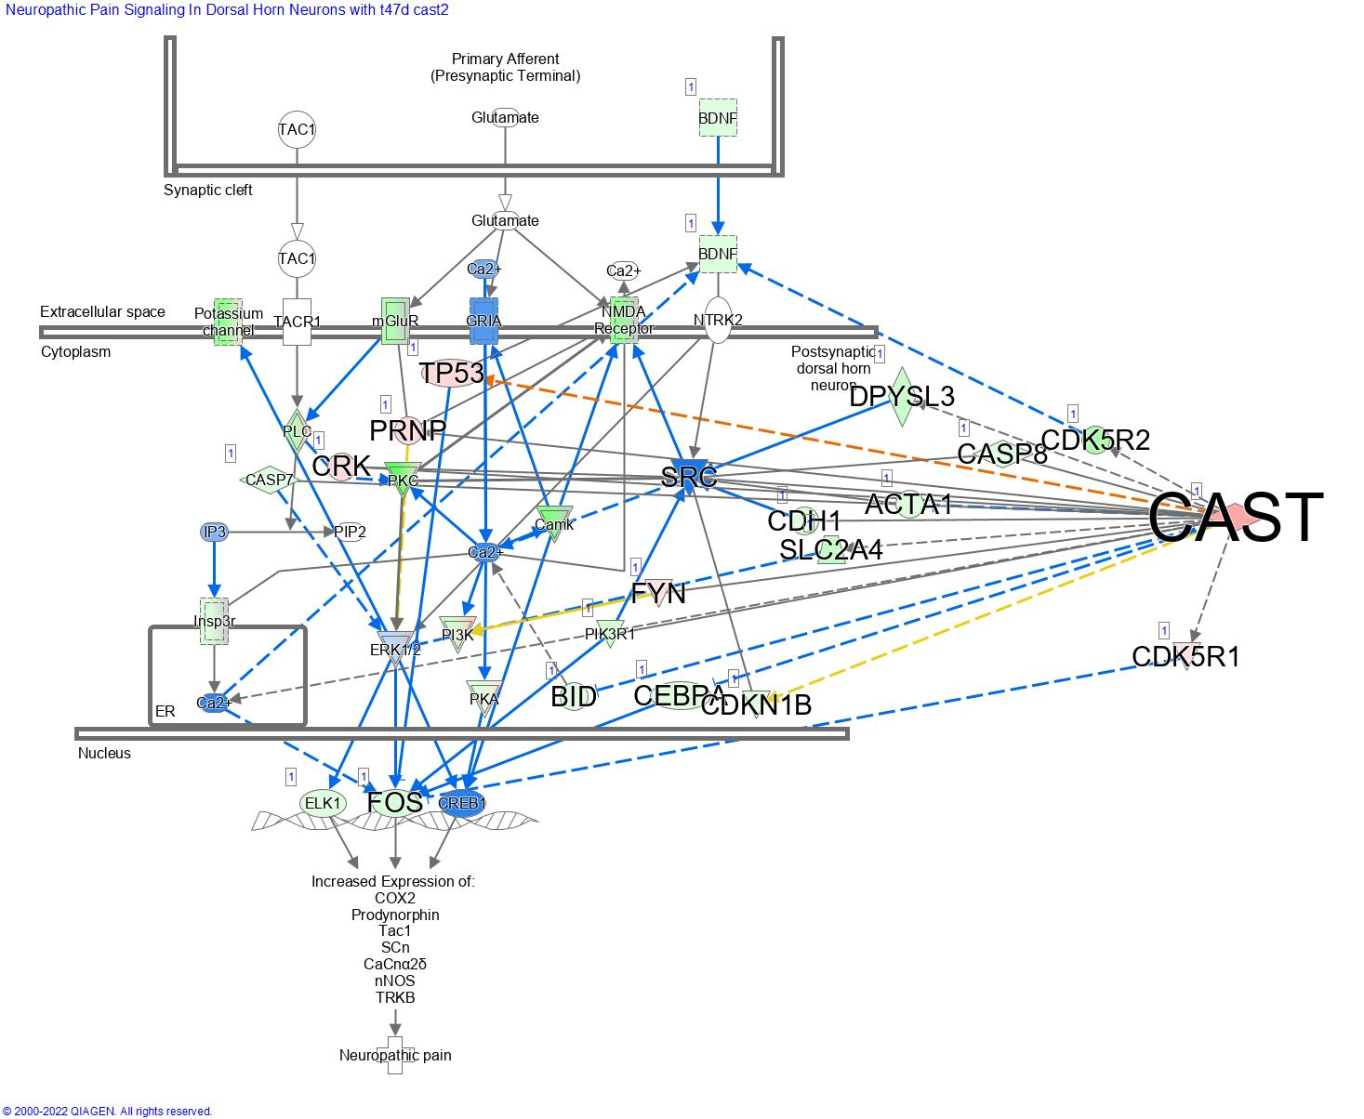**Pathways significantly inhibited by the DEGS associated with the expression of CAST II in T47D cells**. (A) Neuropathic pain signalling in dorsal horn neurons, (B) GPCR-mediated nutrient sensing in enteroendocrine cells, (C) Synaptogenesis signalling pathway, (D) CDK5 signalling, (E) G beta gamma signalling.

**A**

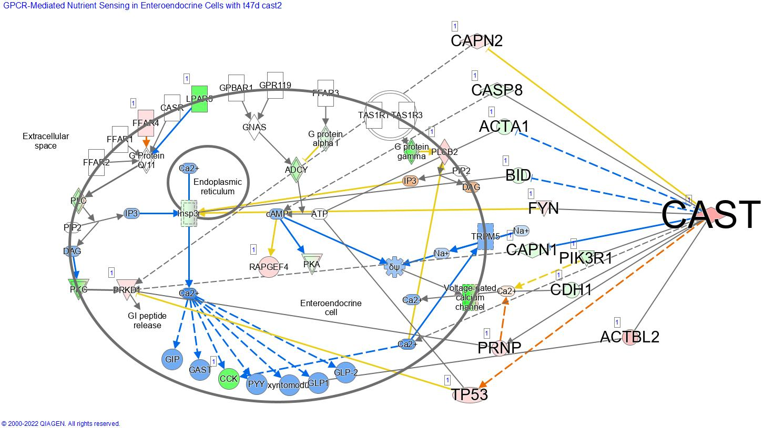

**B**

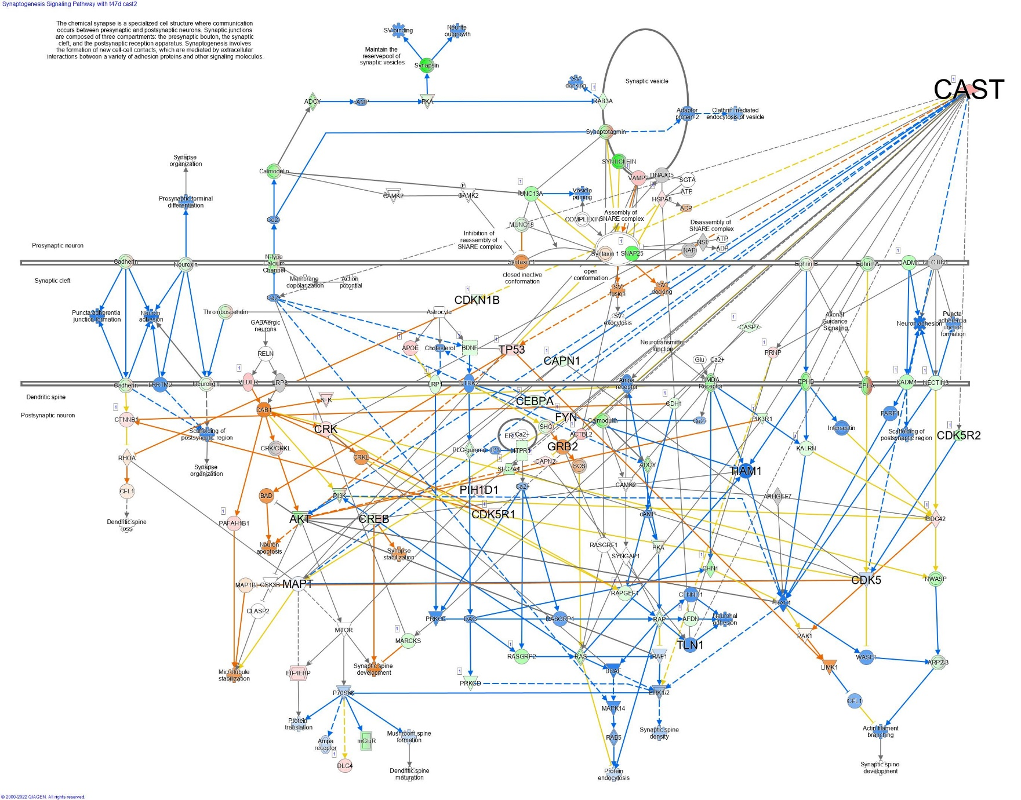

**C**

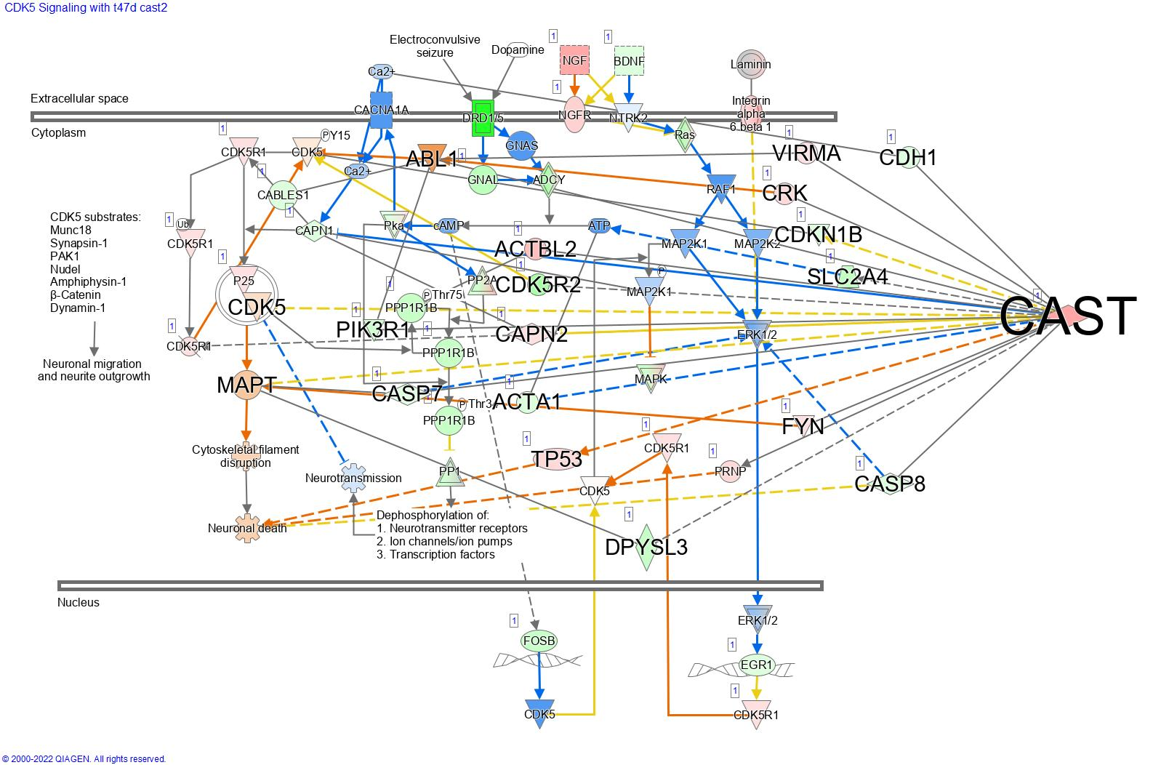

**D**

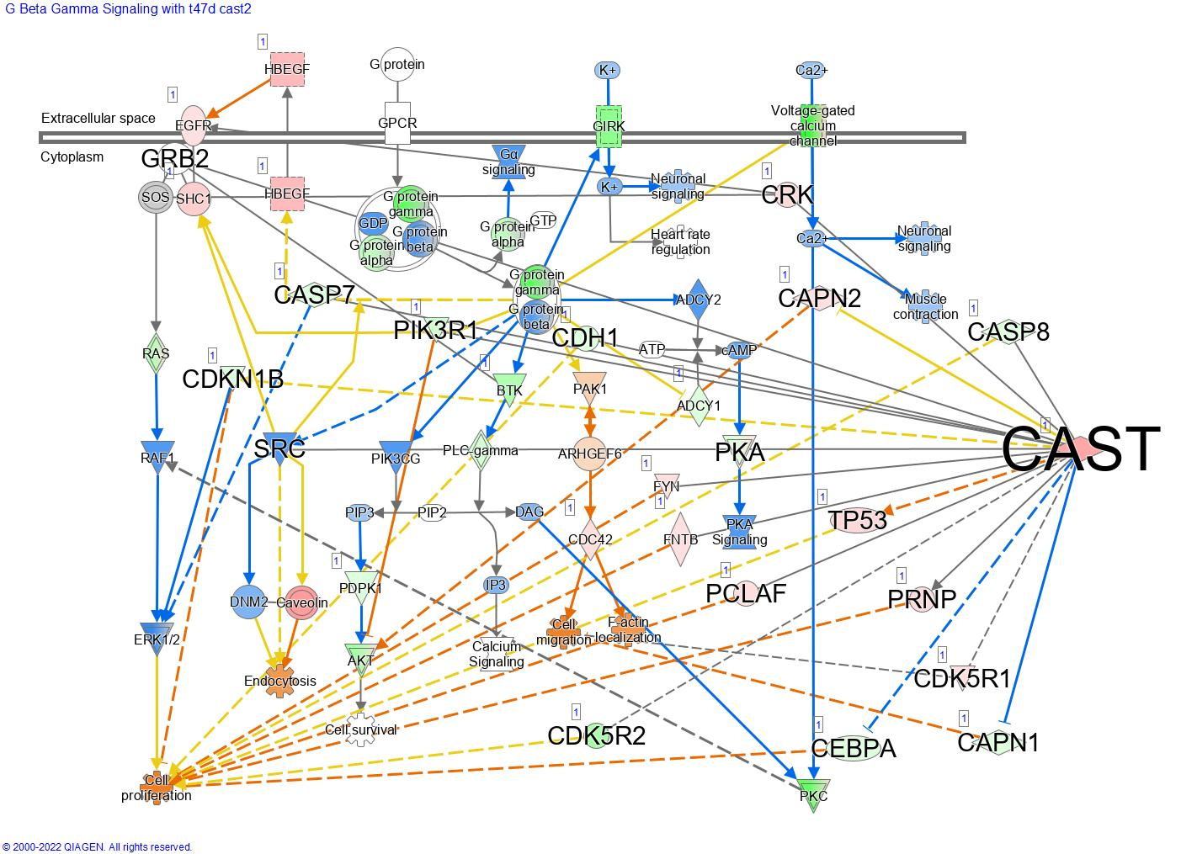

**E**

**Pathways significantly activated by the DEGS associated with the expression of CAST II in T47D cells.** (A) PD-1, PD-L1 cancer immunotherapy pathway, (B) Apelin adipocyte signalling pathway, (C) Inhibition of angiogenesis by TSP1, (D) PI3K/AKT signalling, (E) ILK signalling.

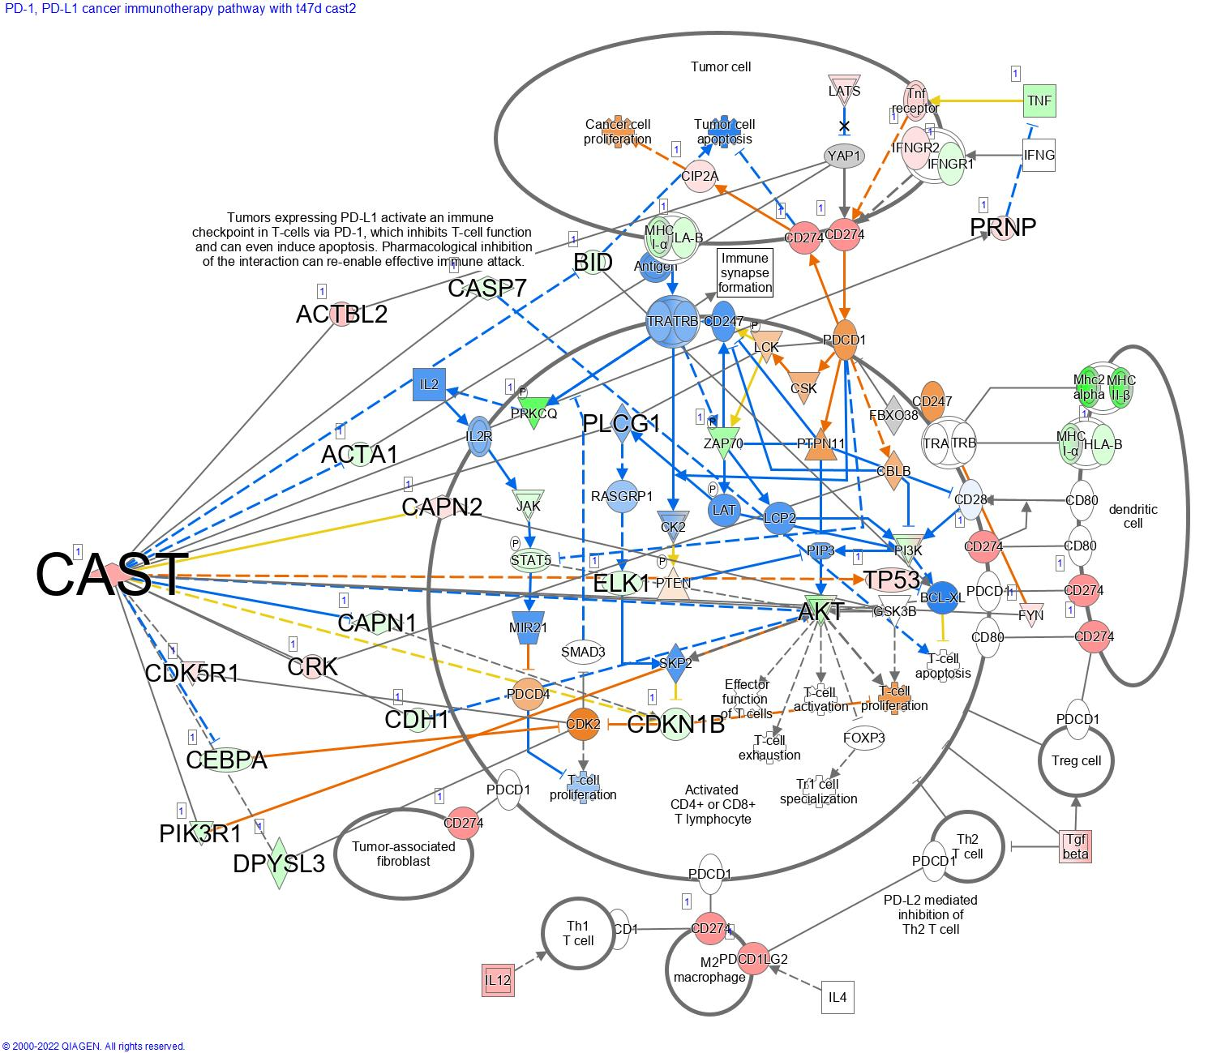

**A**

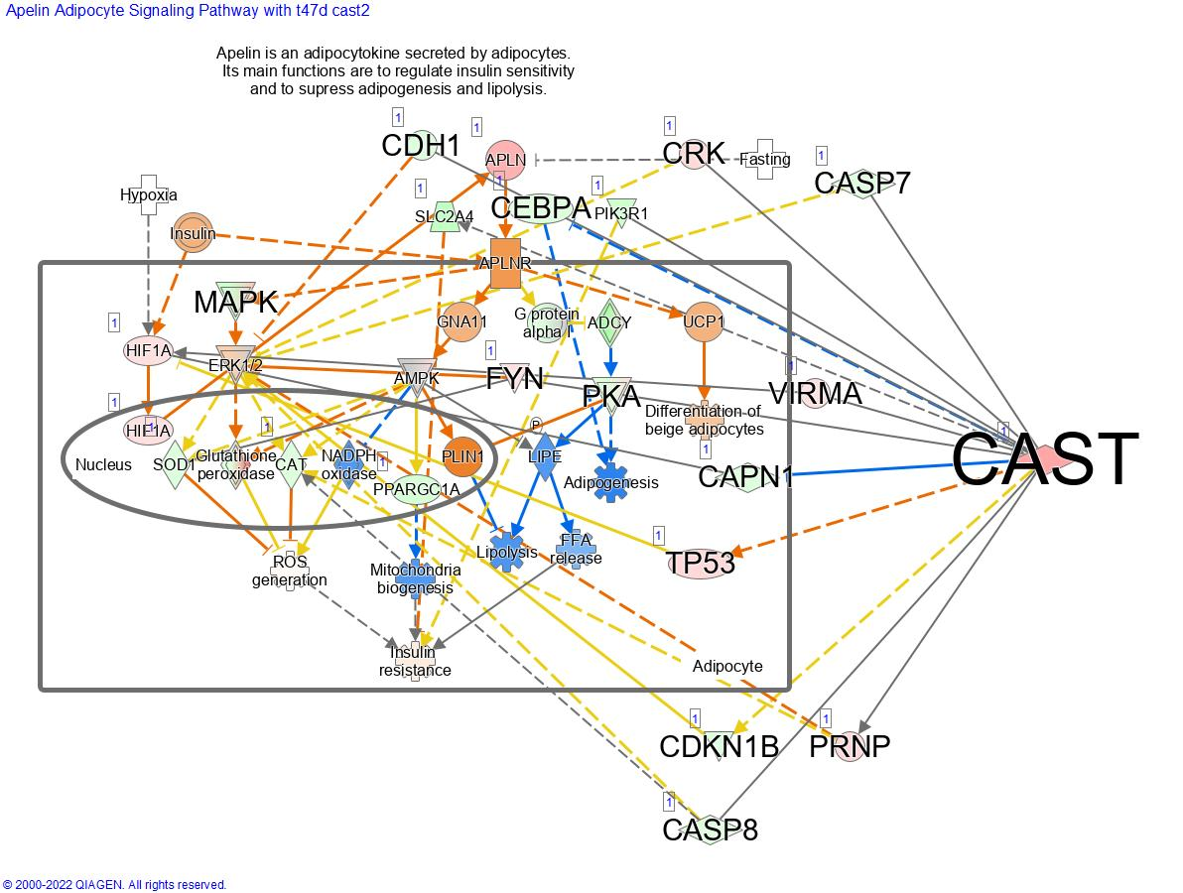

**B**

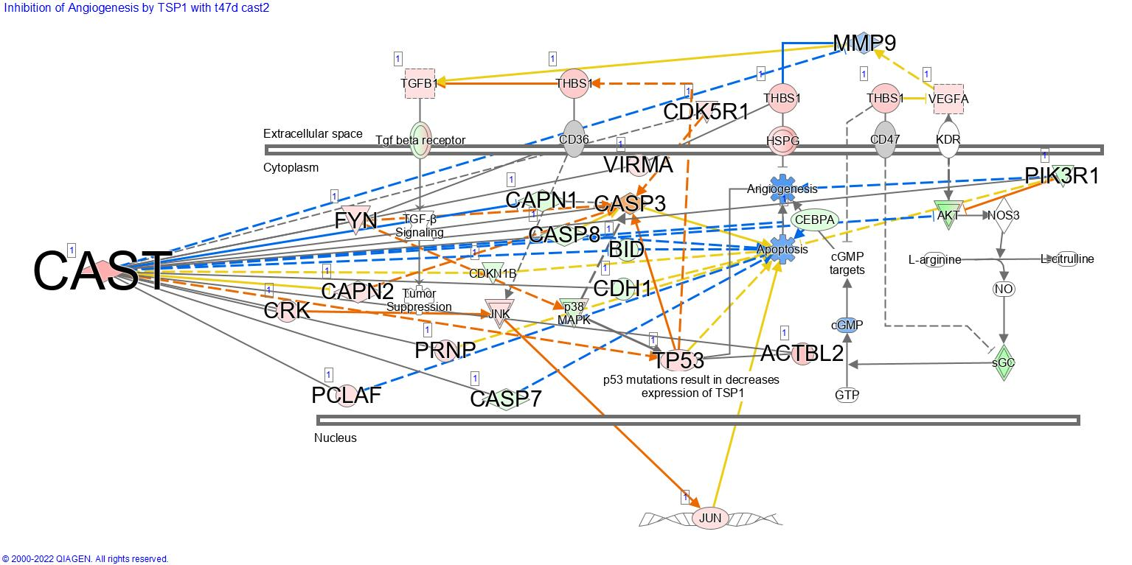

**C**

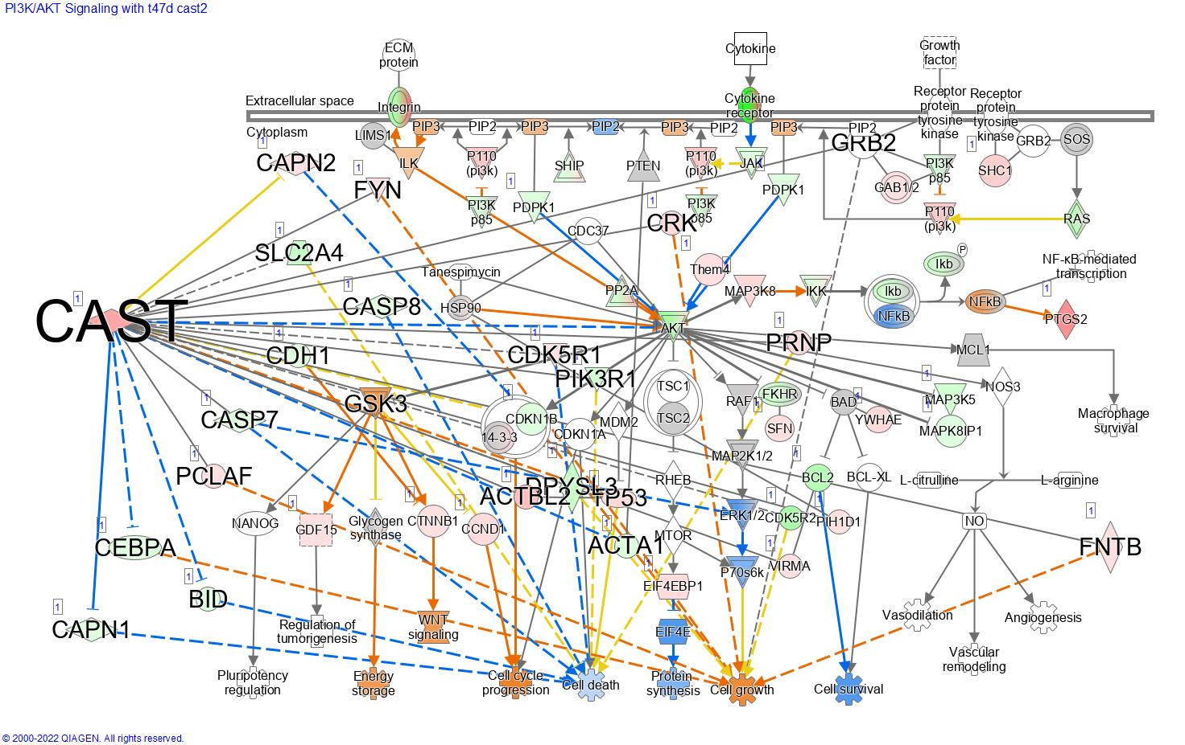

**D**

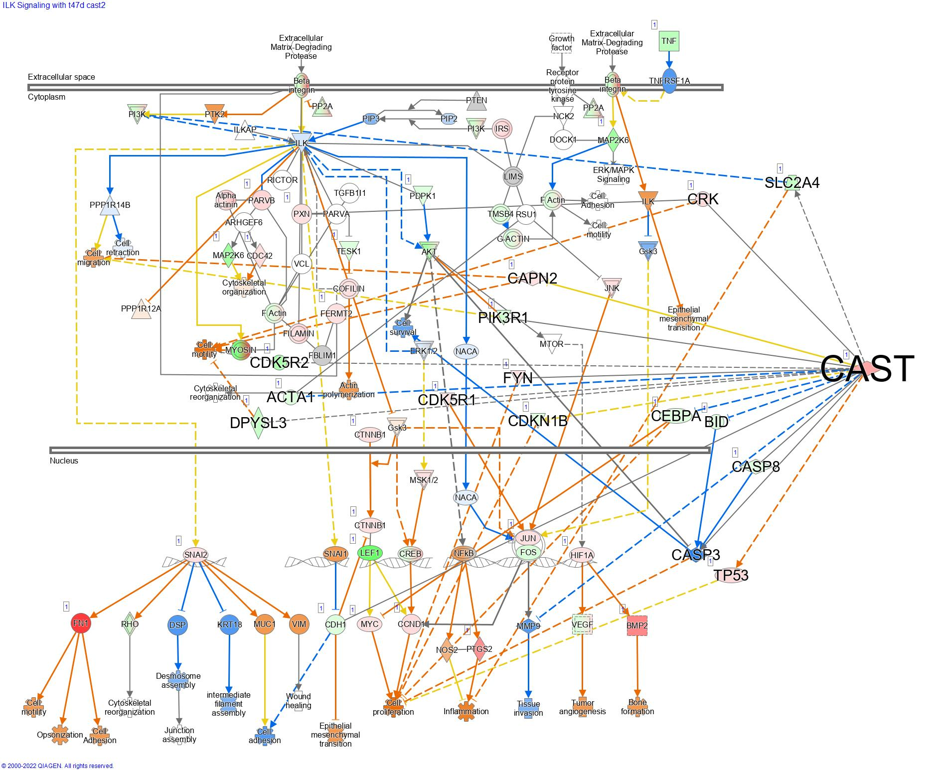

**E**

## Pathways significantly altered by DEGS associated with calpastatin type III expression in T47D cells

**Pathways significantly inhibited by the DEGS associated with the expression of CAST III in T47D cells.** Cyclins and cell cycle regulation pathway

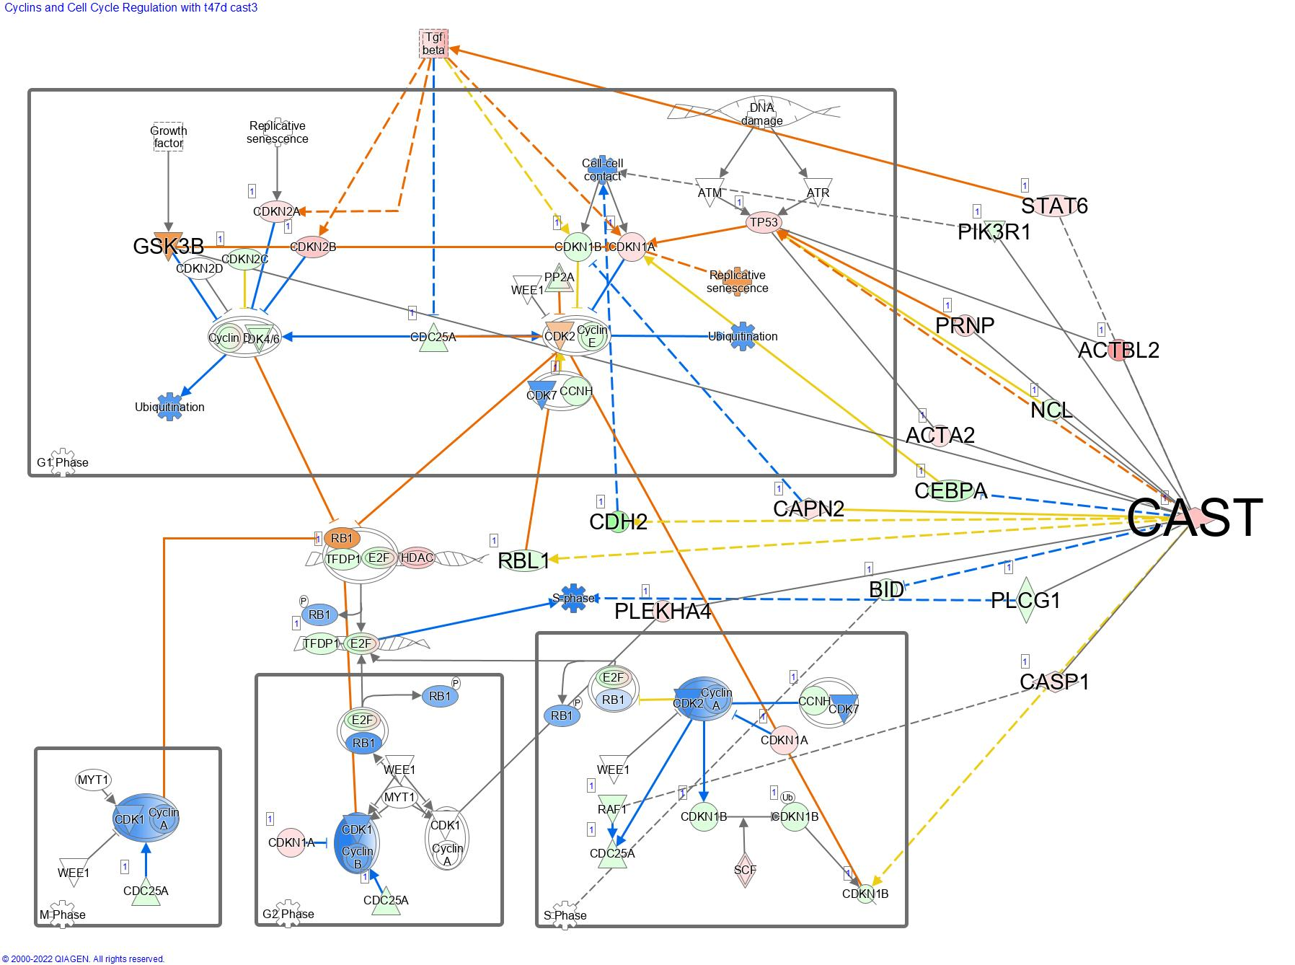

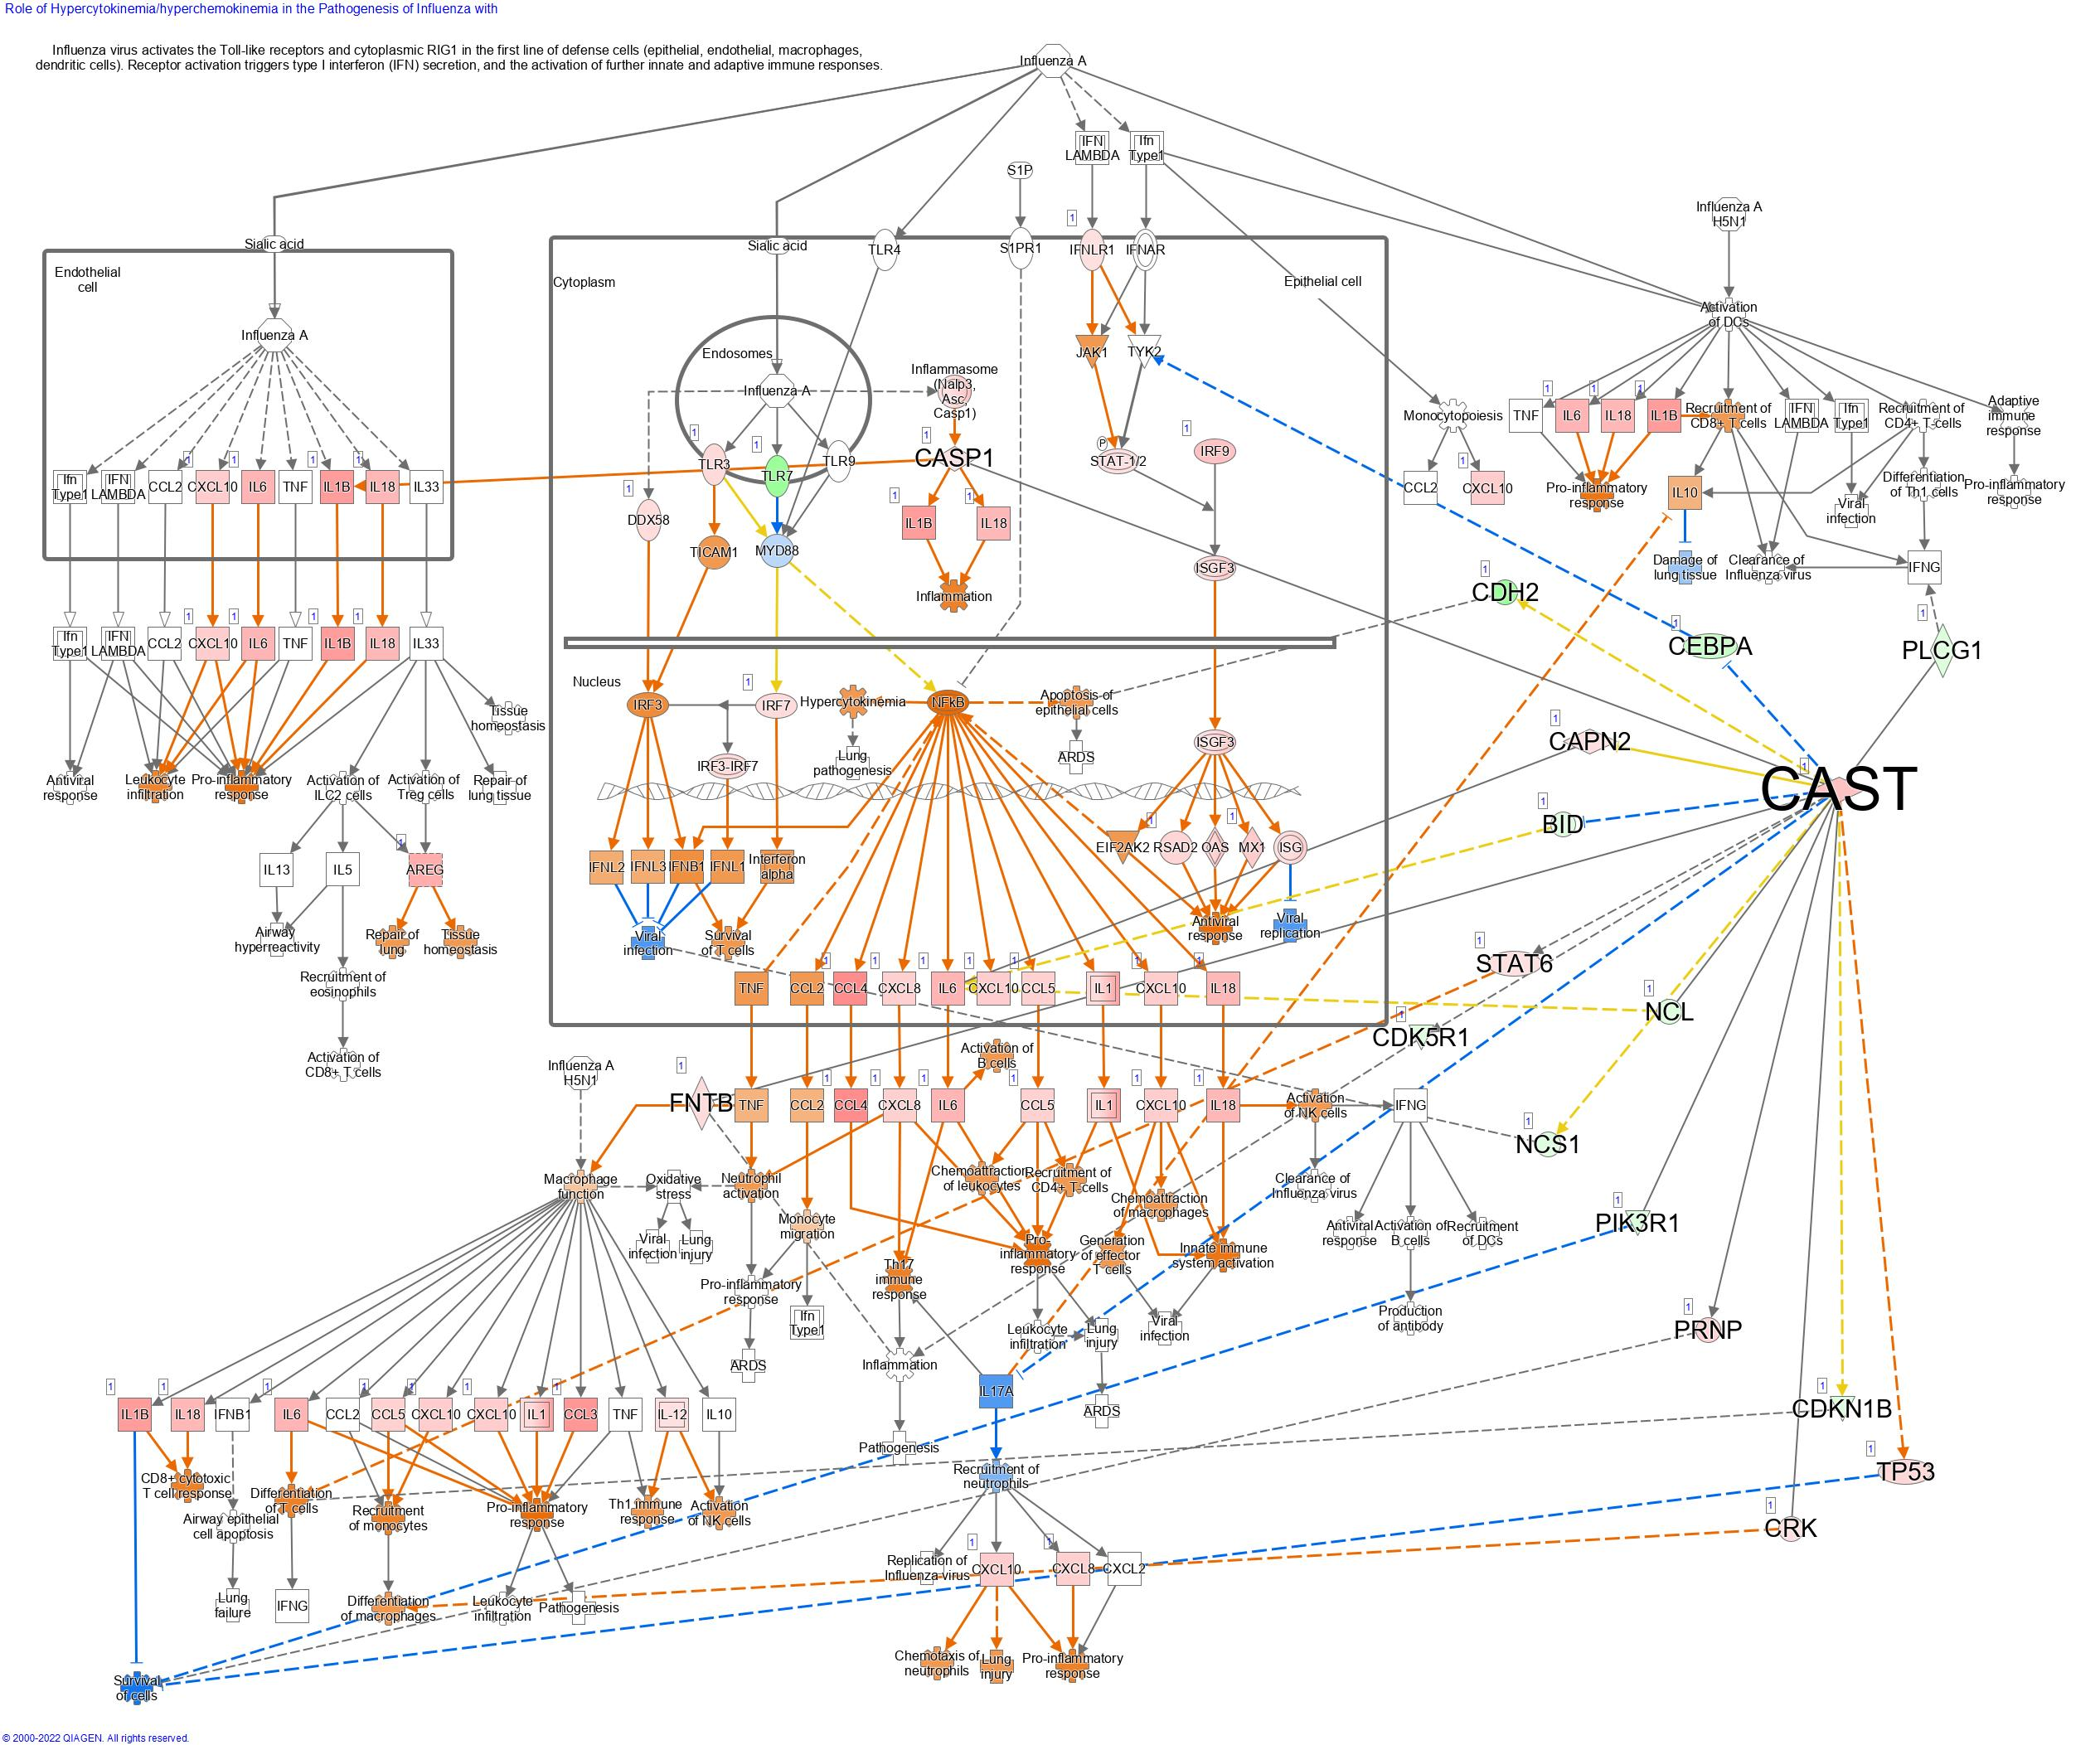**Pathways significantly activated by the DEGs associated with the expression of CAST III in T47D cells.** (A) Role of hypercytokinemia.hyperchemokinemia in the pathogenesis of influenza, (B) Wound healing signalling pathway, (C) Tumour microenvironment pathway, (D) Neuroinflammation signalling pathway, (E) Interferon signalling, (F) Pulmonary fibrosis idiopathic signalling pathway, (G) Neuroprotective role of THOP1 in Alzheimer’s disease, (H) PAK signalling, (I) ILK signalling, (J) PI3K/AKT signalling.

**A**

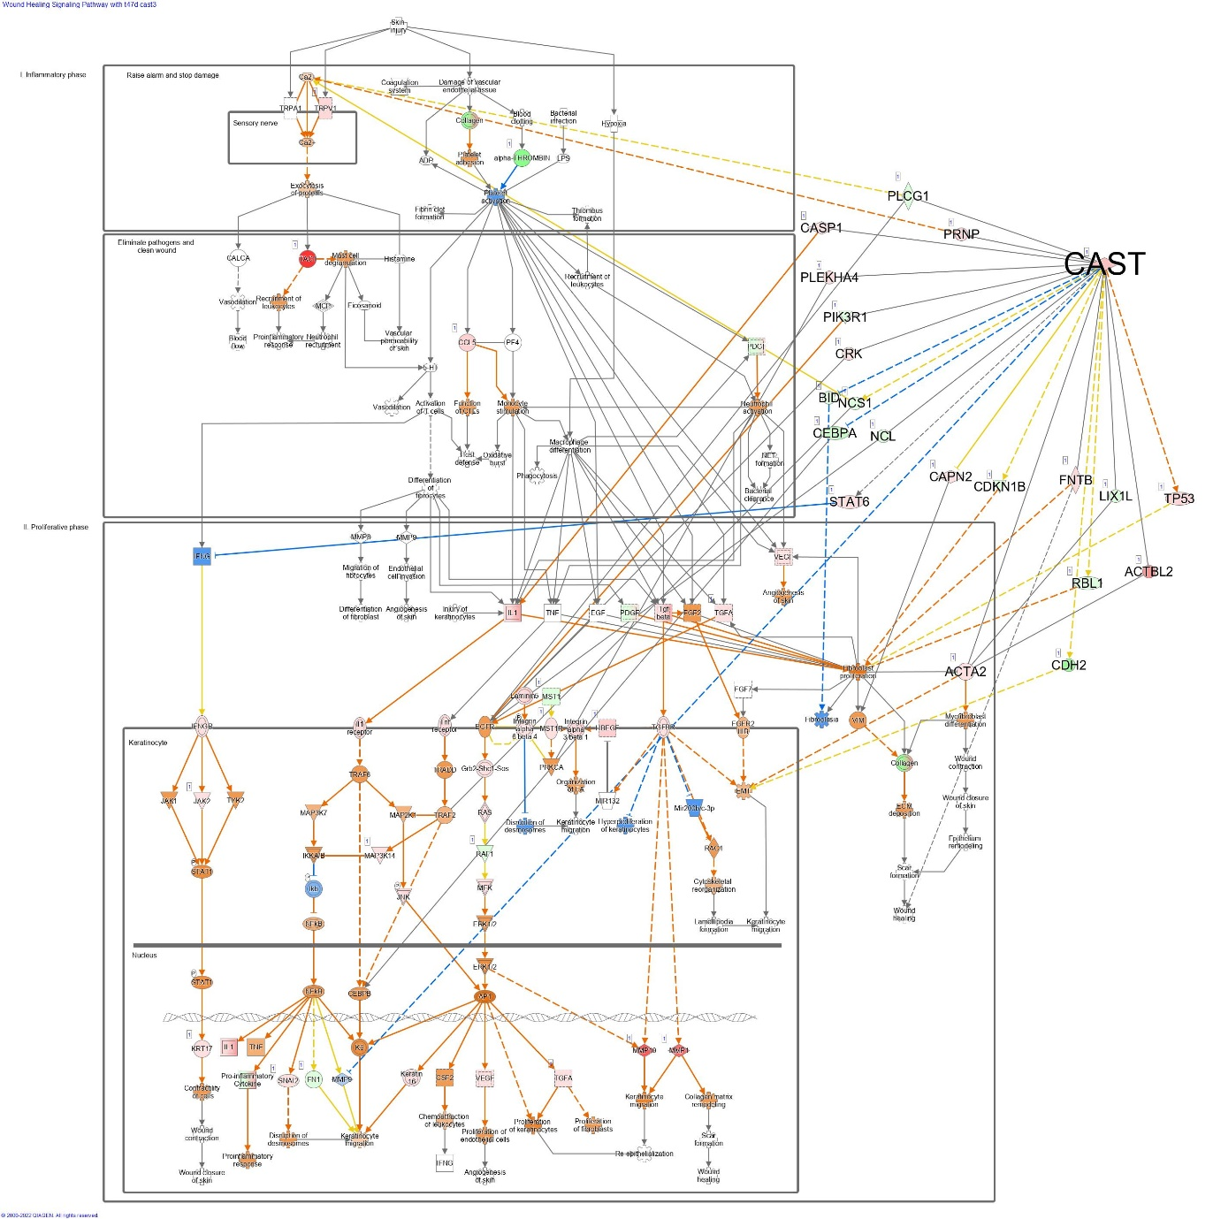

**B**

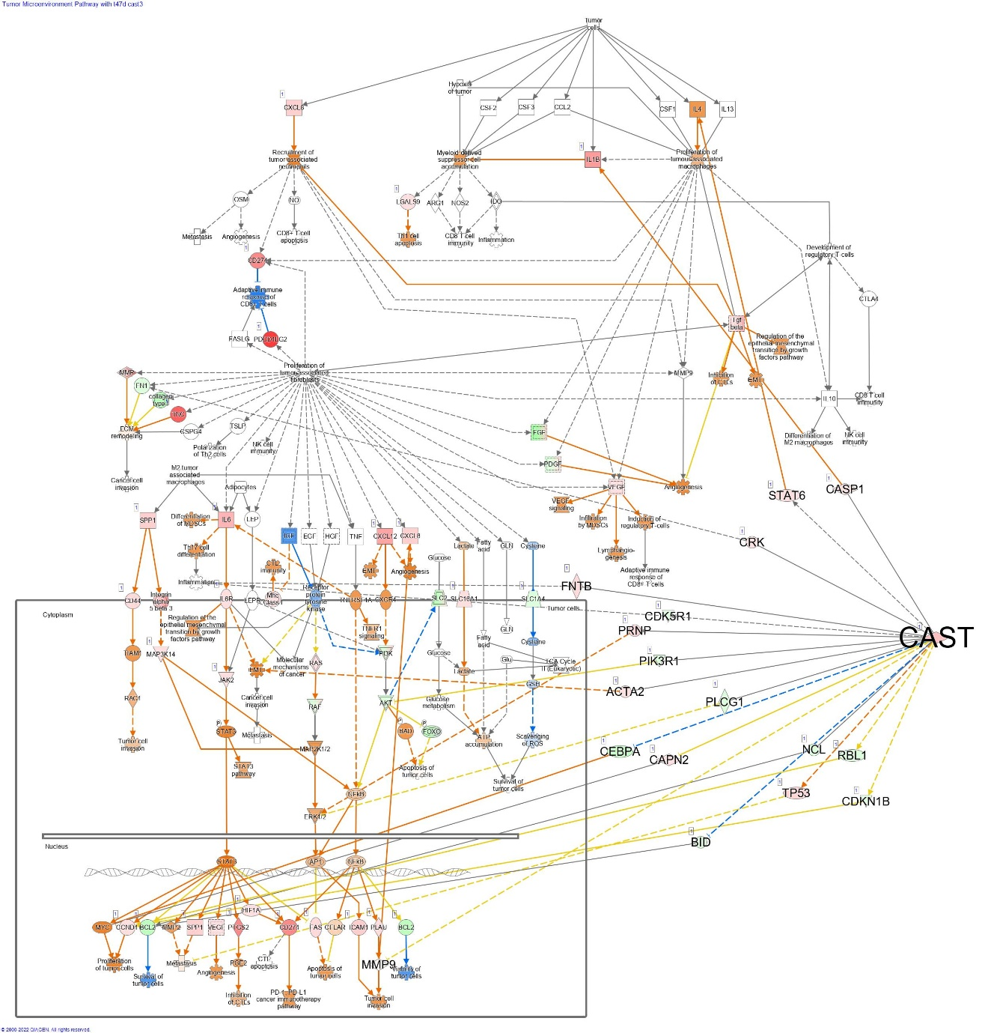

**C**

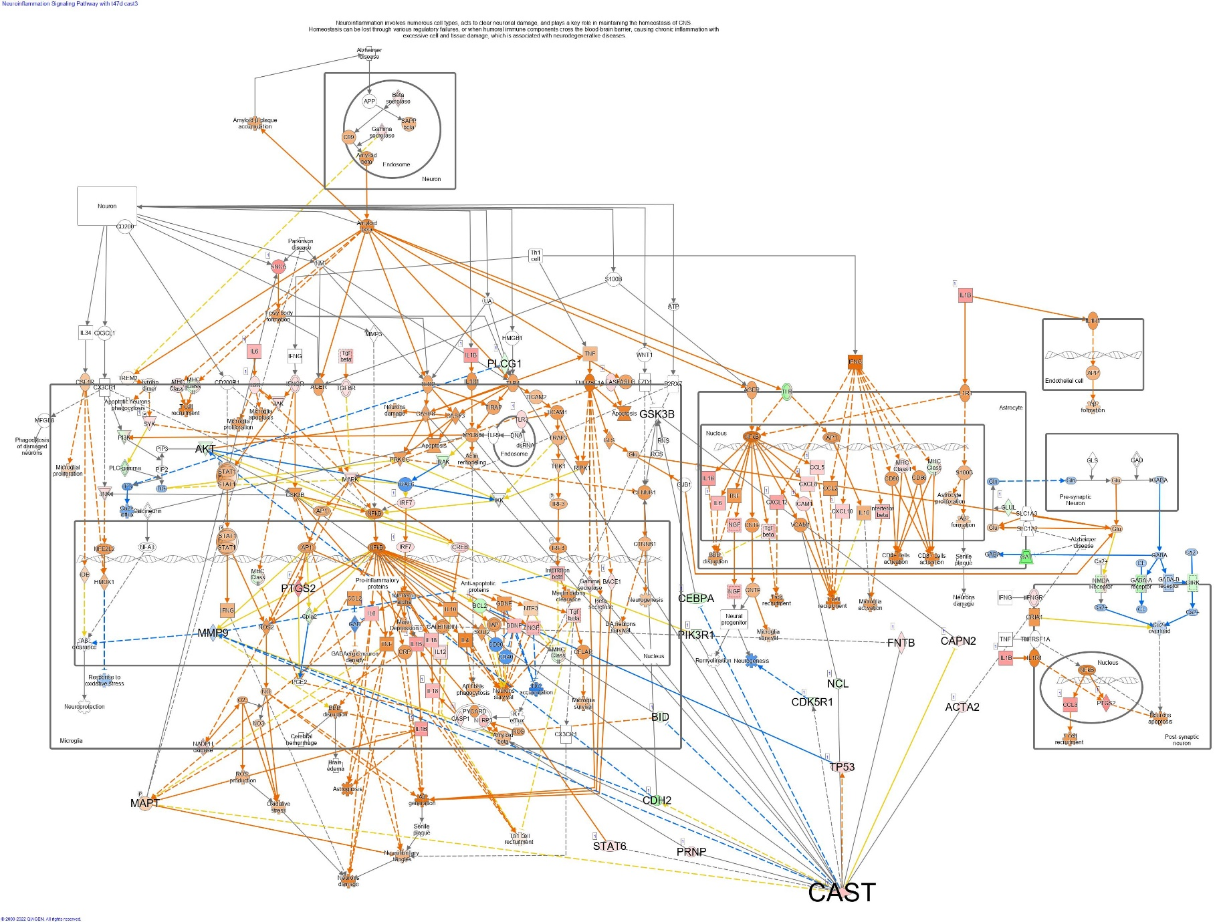

**D**

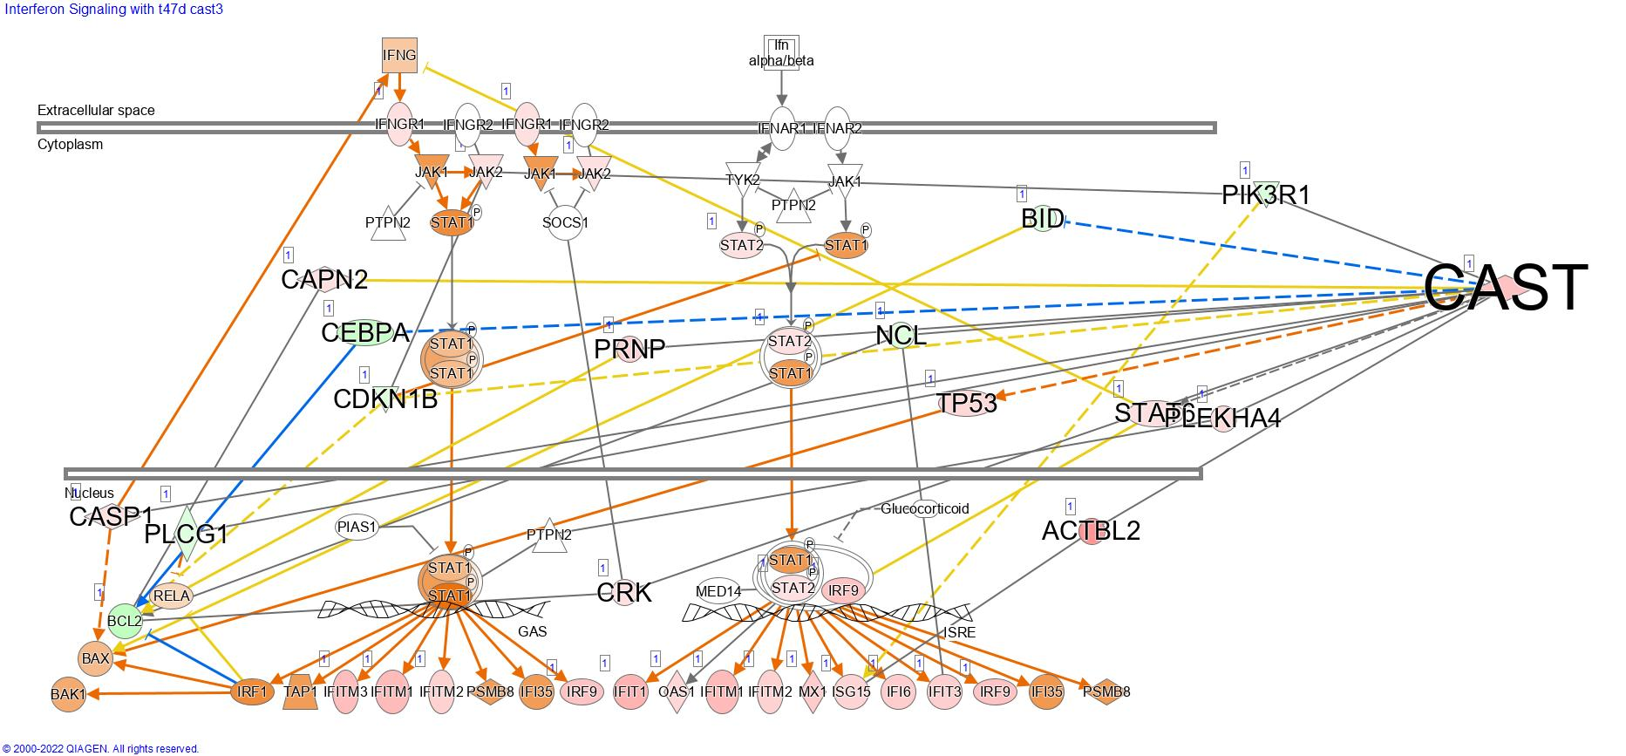

**E**

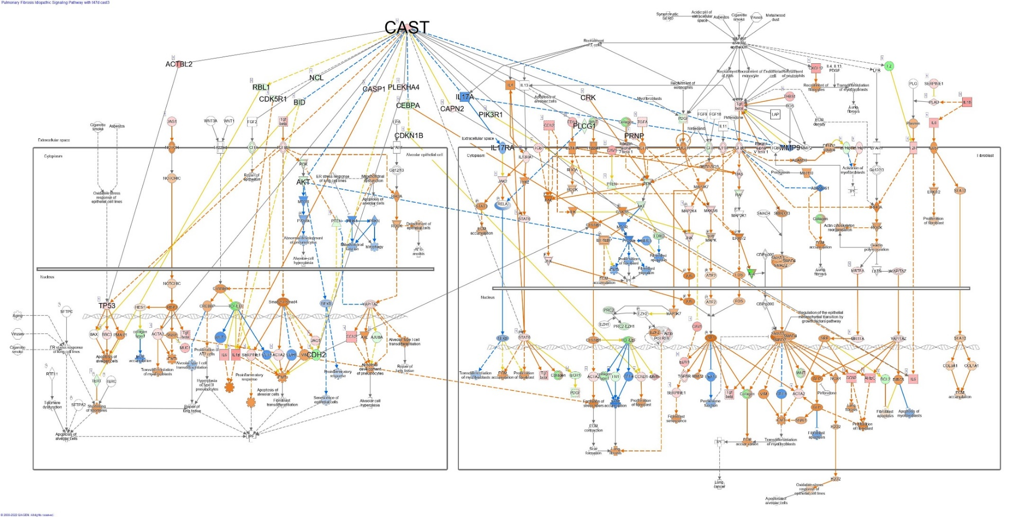

**F**

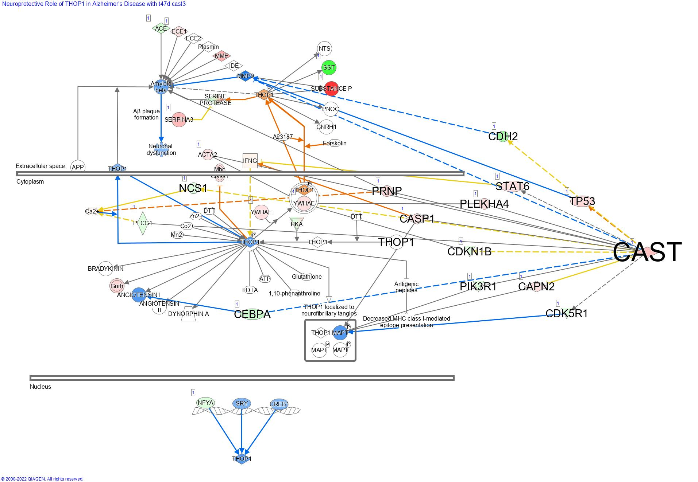

**G**

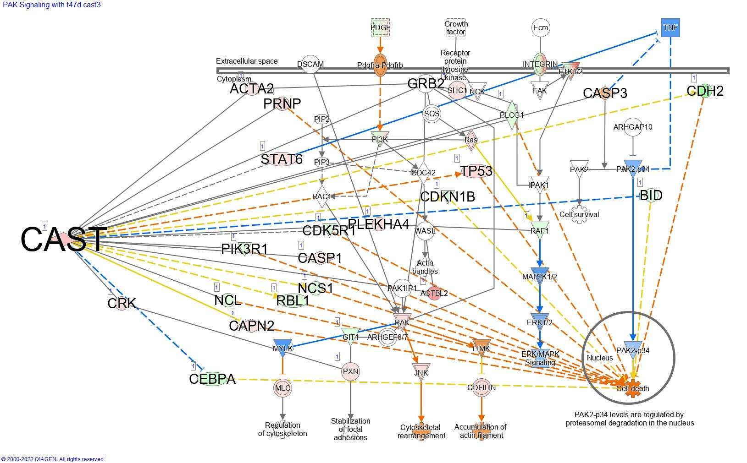

**H**

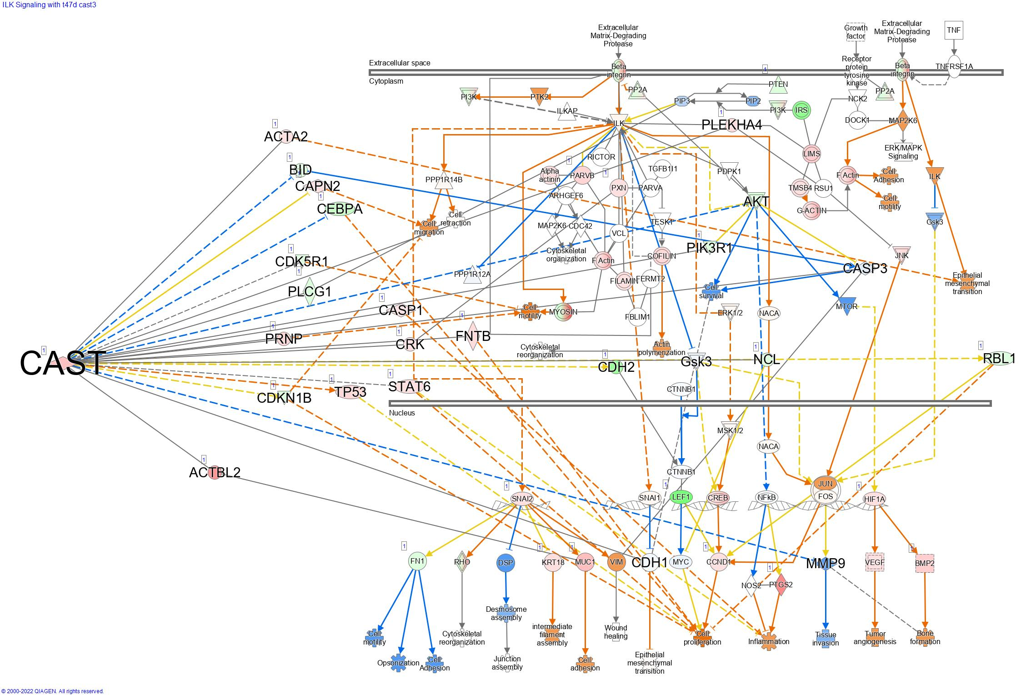

**I**

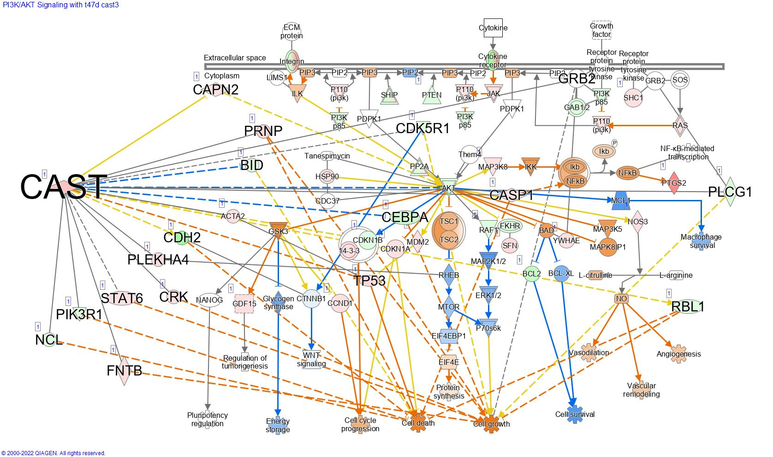

**J**

## Pathways significantly altered by DEGS associated with calpastatin type I expression in MDA-MB-231 cells

**Pathways significantly activated by the DEGs associated with the expression of CAST I in MDA-MB-231 cells.** (A) Integrin signalling and (B) Cell cycle control of chromosomal replication

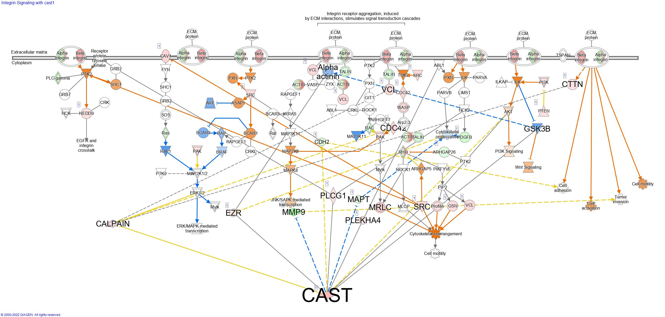

**A**

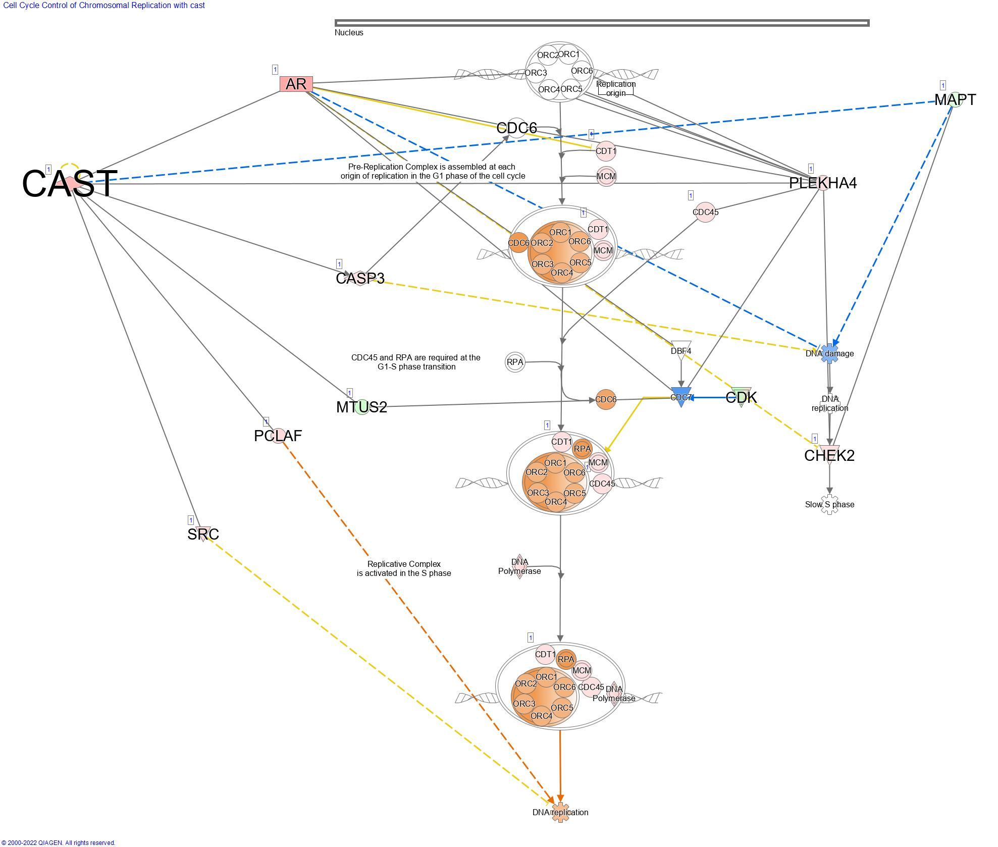

**B**

## Pathways significantly altered by DEGS associated with calpastatin type II expression in MDA-MB-231 cells

**Pathways significantly activated by the DEGs associated with the expression of CAST II in MDA-MB-231 cells.** Endoplasmic reticulum stress pathway

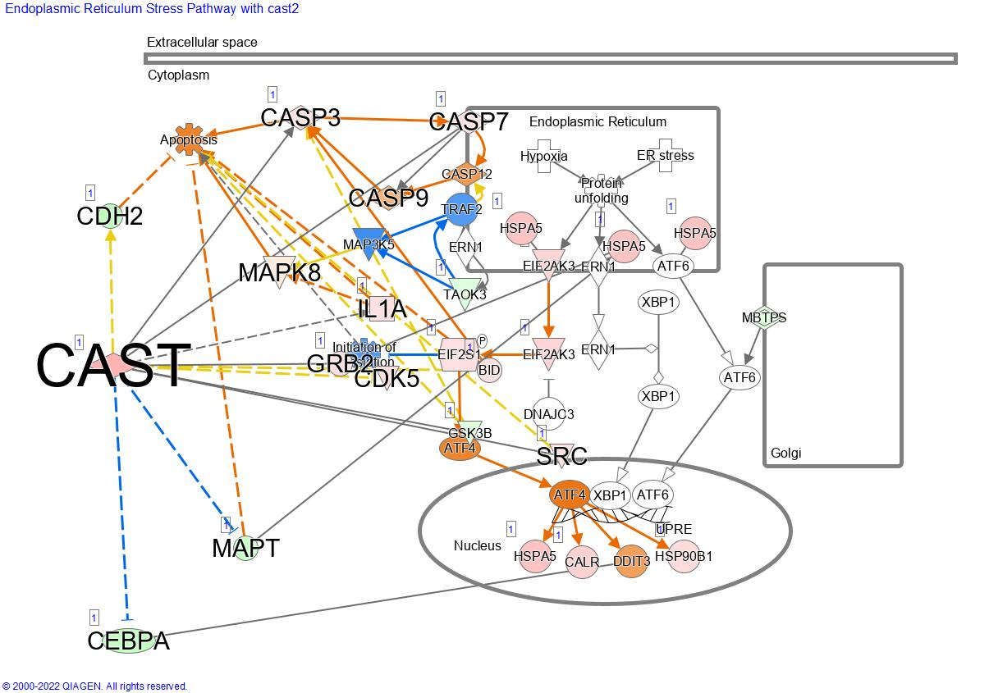

## Pathways significantly altered by DEGS associated with calpastatin type III expression in MDA-MB-231 cells

**Pathways significantly inhibited by the DEGs associated with the expression of CAST III in MDA-MB-231 cells.** (A) CREB signalling in neurons, (B) Pulmonary fibrosis idiopathic signalling pathway, (C) coronavirus pathogenesis pathway, (D) Wound healing signalling pathway, (E) Neuroinflammation signalling pathway, (F) TREM1 signalling, (G) Phagosome formation, (H)Pyroptosis signalling pathway, (I) Hepatic fibrosis signalling pathway, (J) Acute phase response signalling.

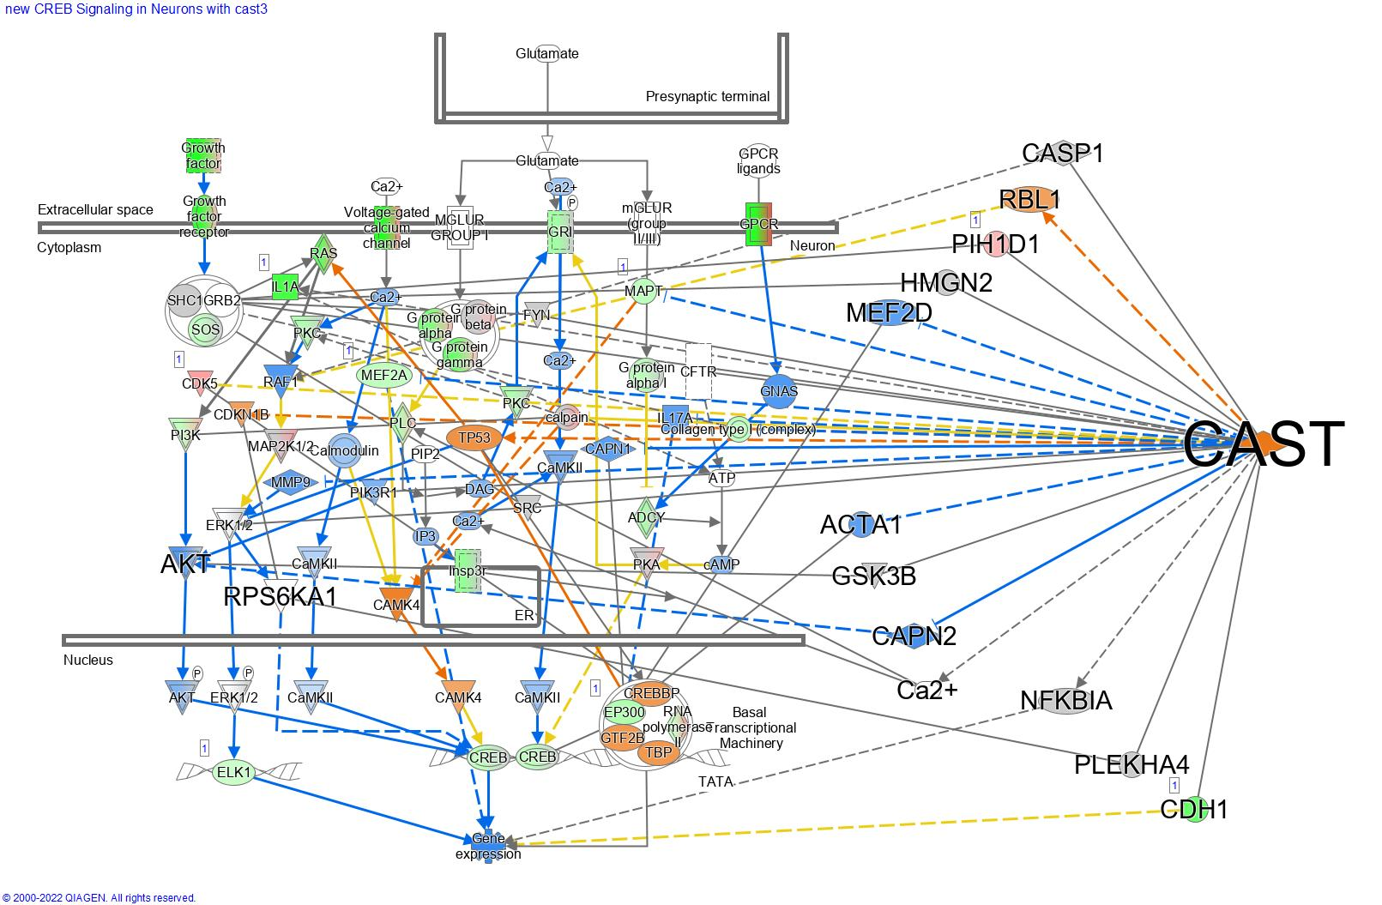

**A**

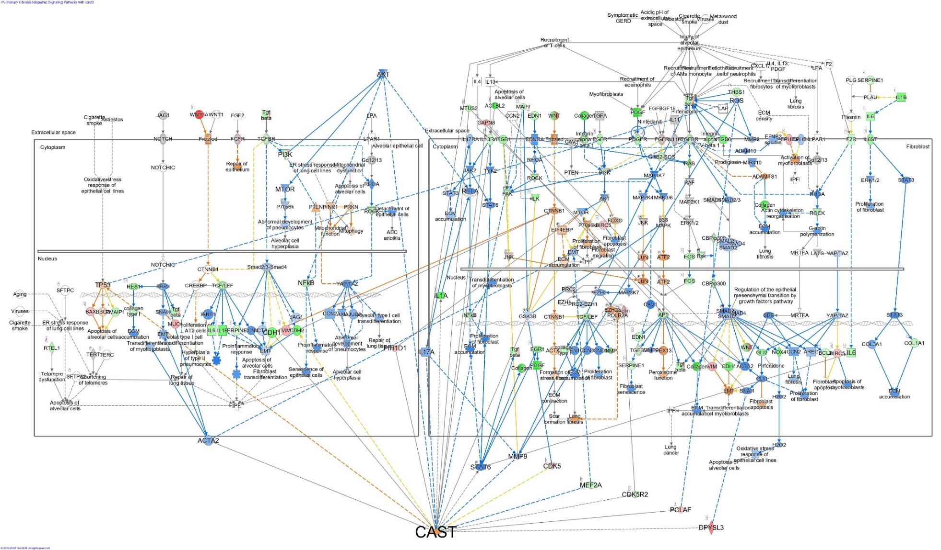

**B**

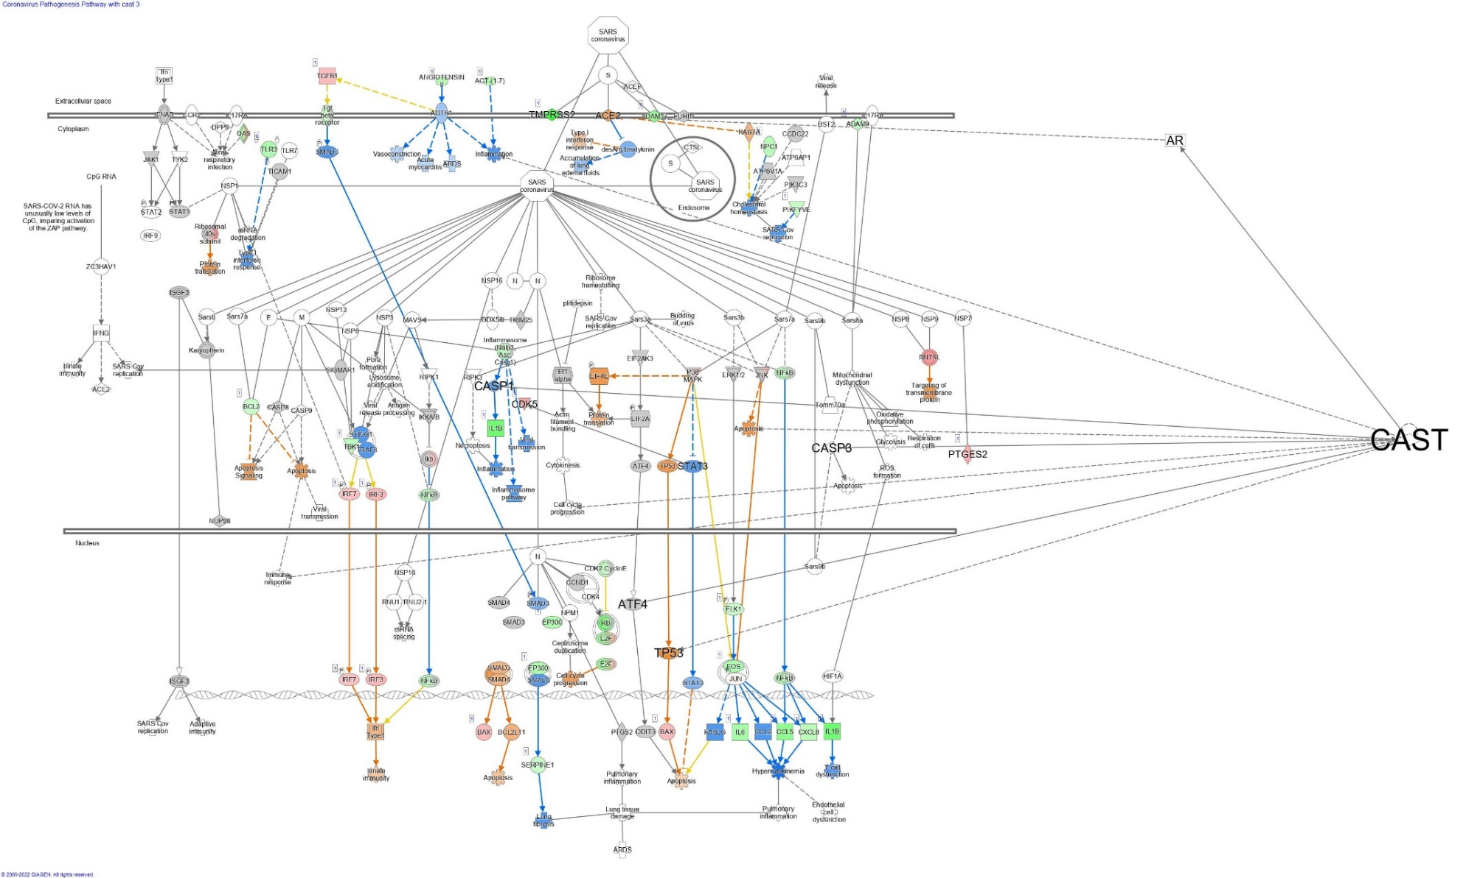

**C**

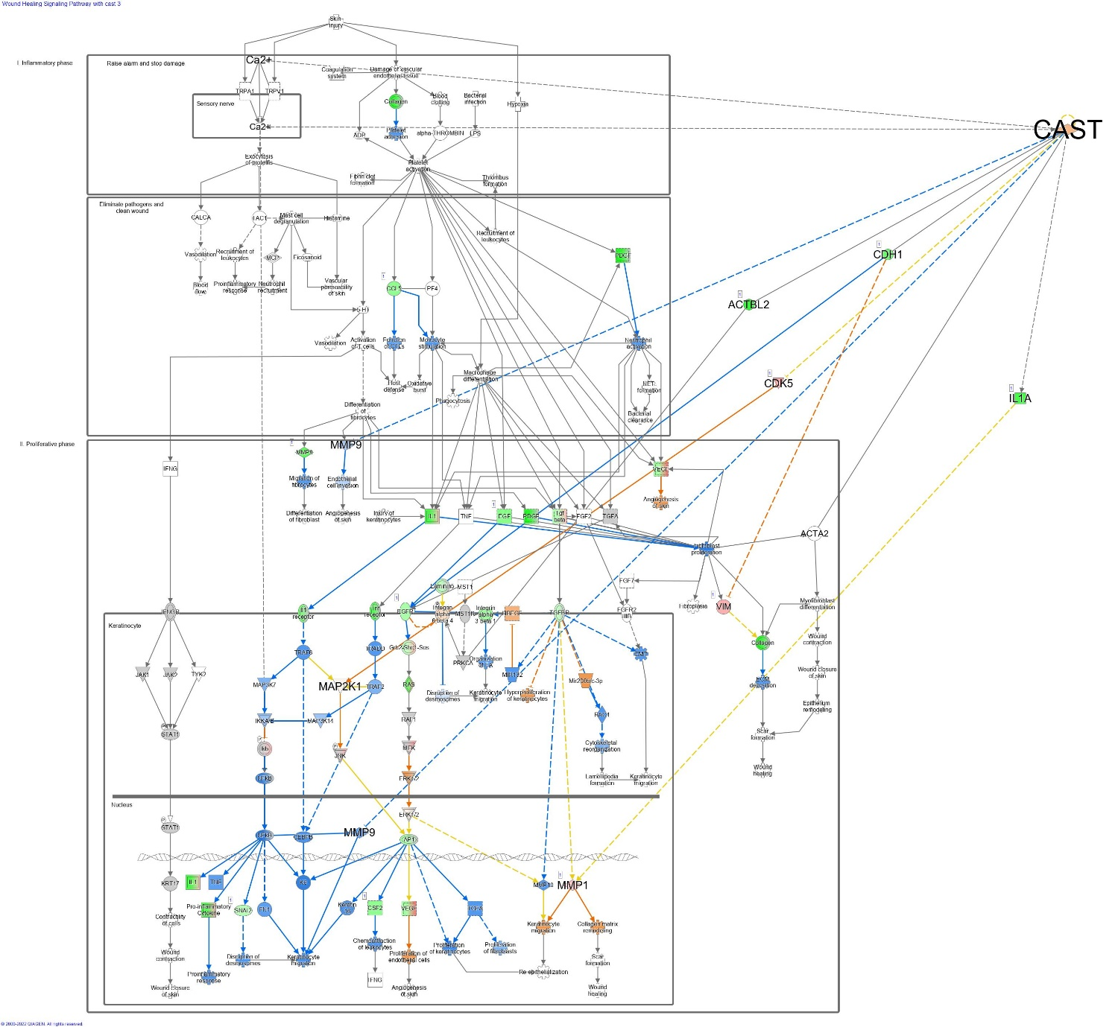

**D**

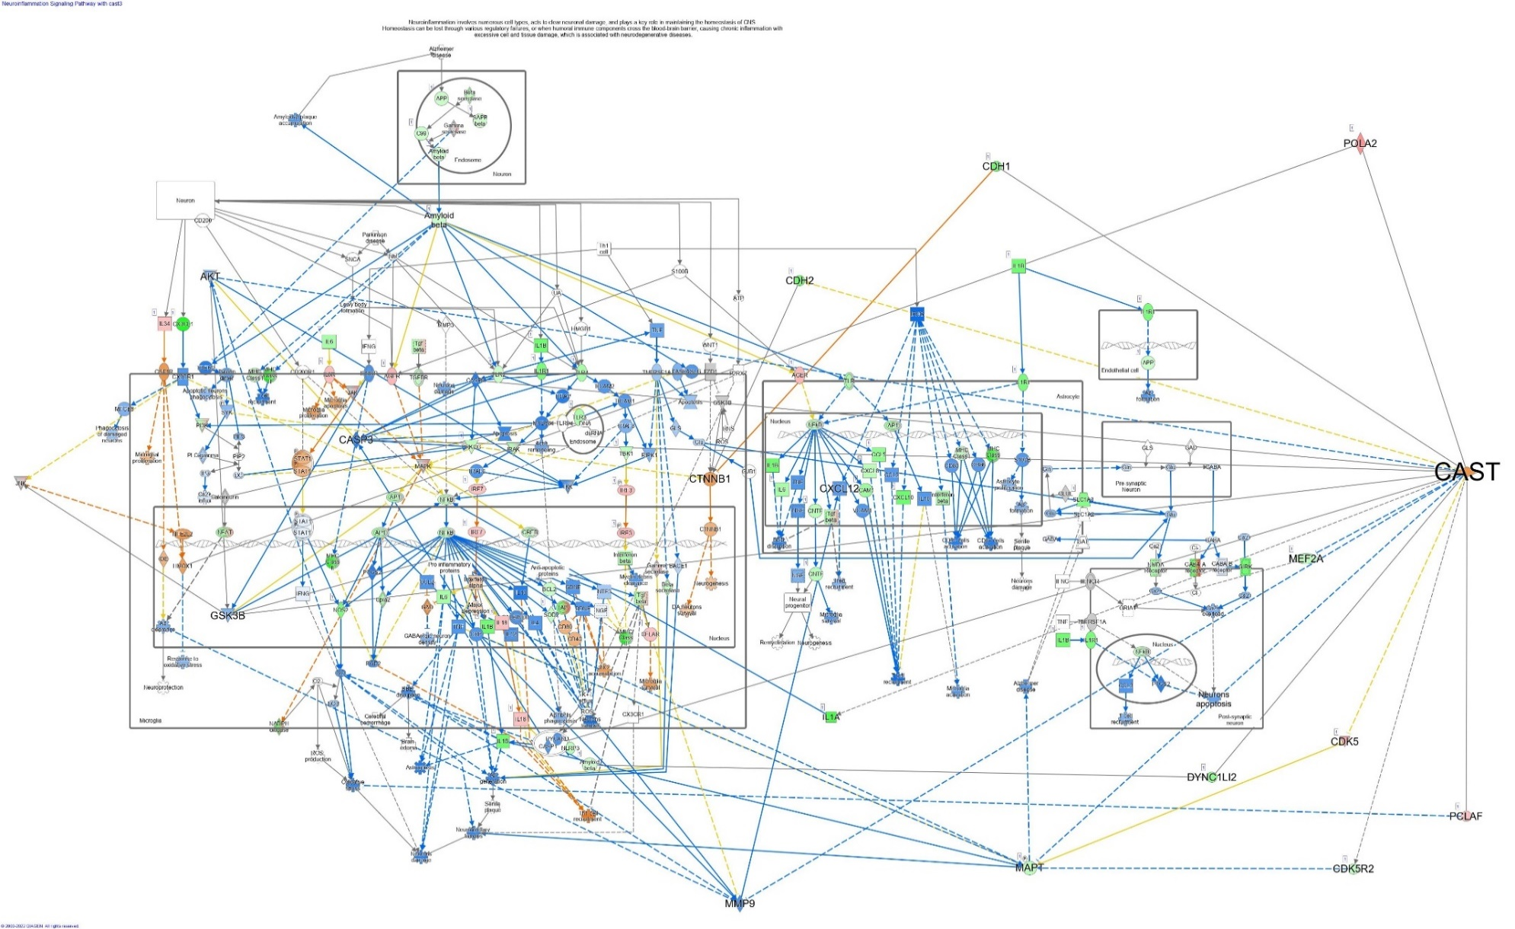

**E**

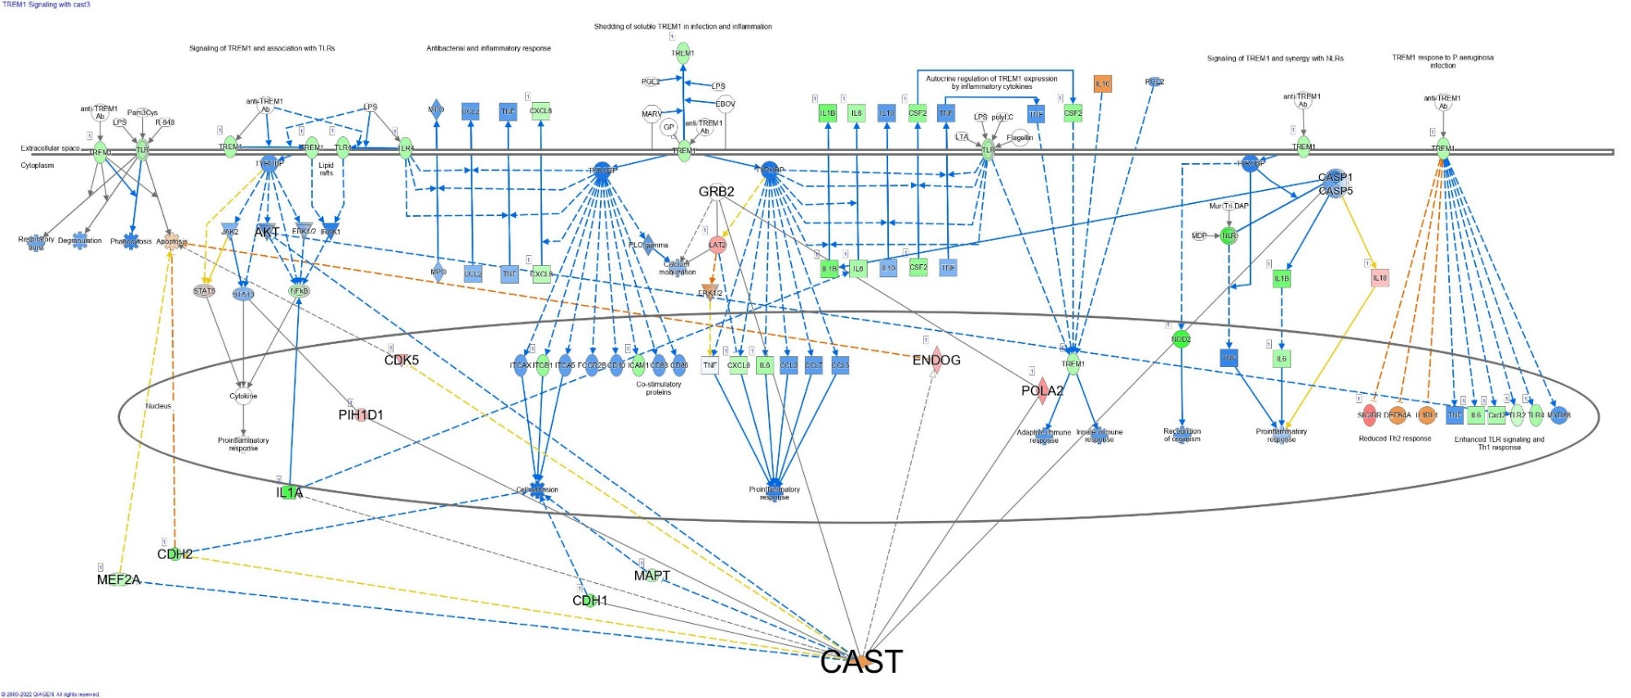

**F**

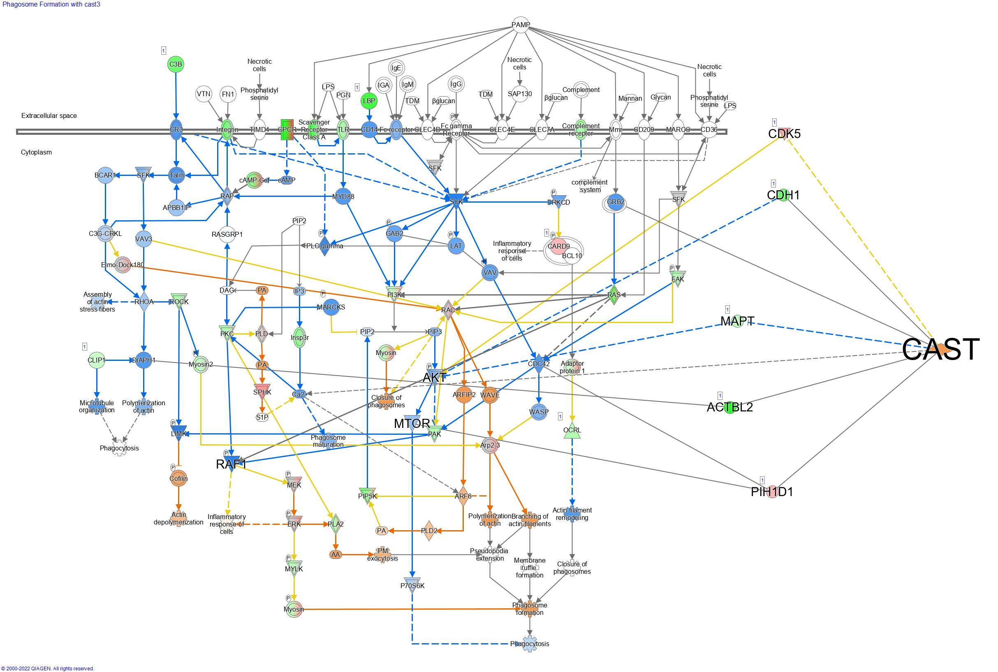

**G**

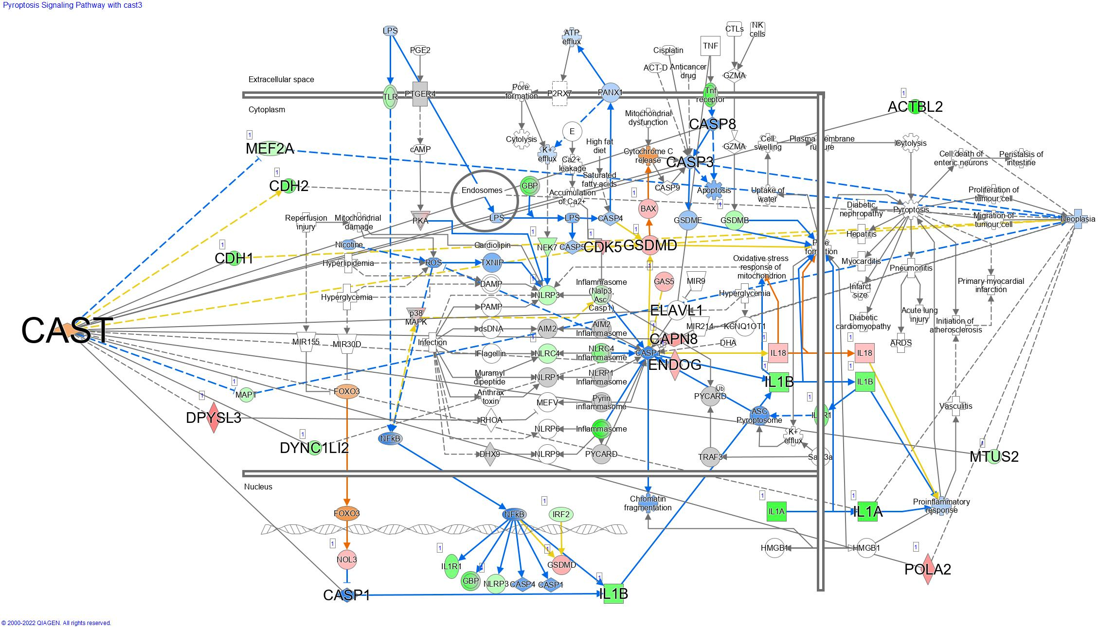

**H**

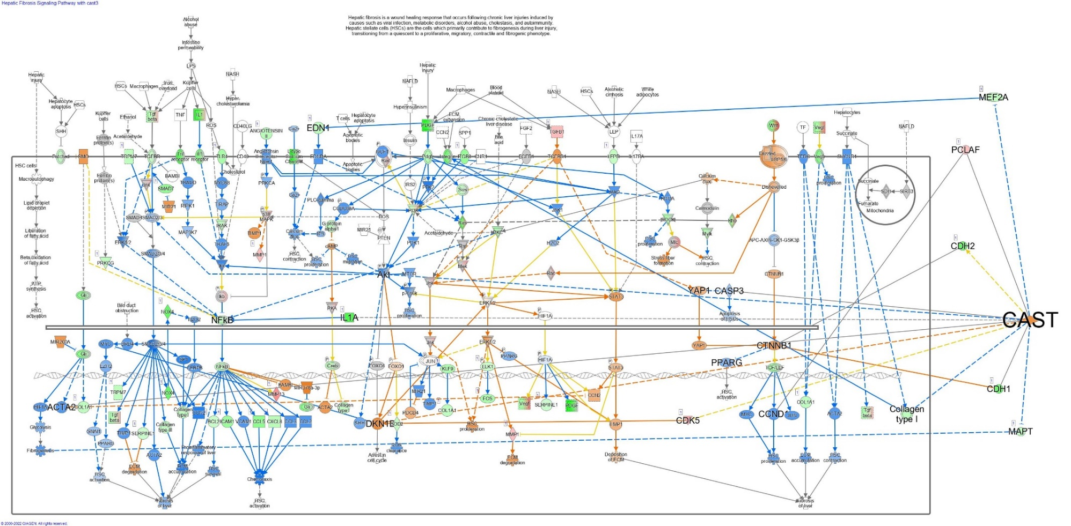

**I**

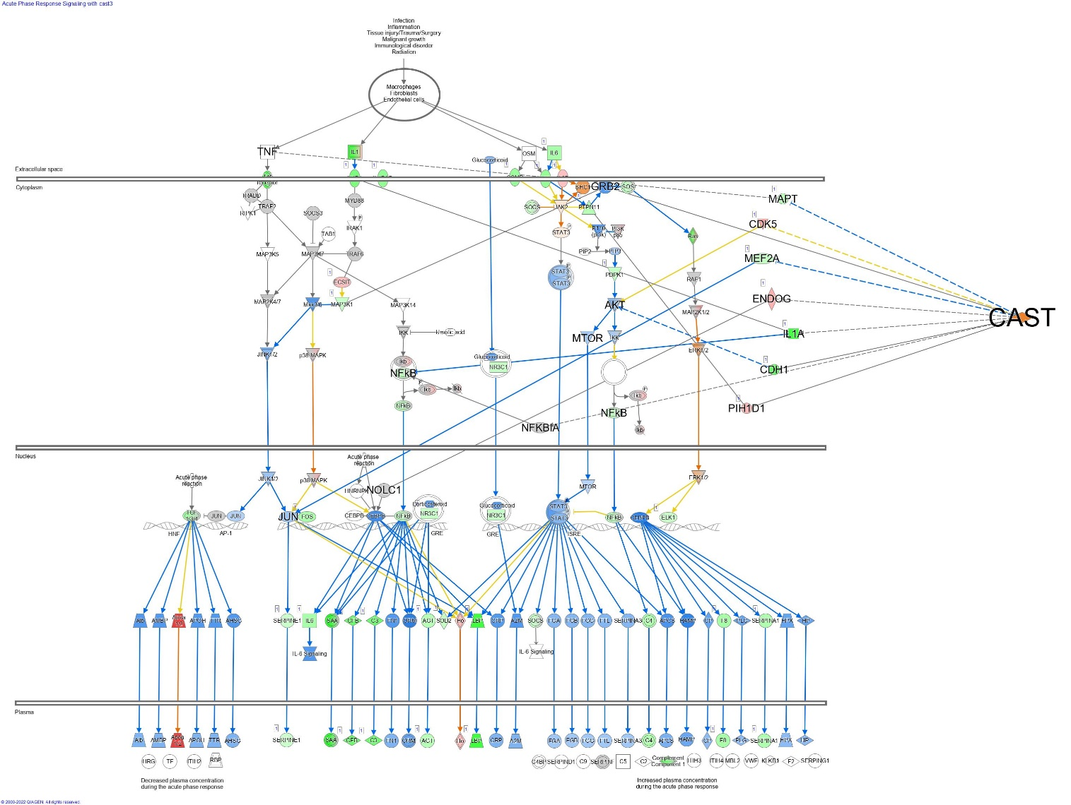

**J**

**Pathways significantly activated by the DEGs associated with the expression of CAST III in MDA-MB-231 cells.** EIF2 signalling pathway

